INDRAPRASTHA COLLEGE FOR WOMEN
UNIVERSITY OF DELHI

SESSION:

PRACTICAL FILE
DATA MINING

SUBMITTED BY:
NAME:
ROLL NO:
COURSE: B.Sc. (H) Computer Science
SEMESTER: 6

Q1.Create a file “people.txt” with the following data:
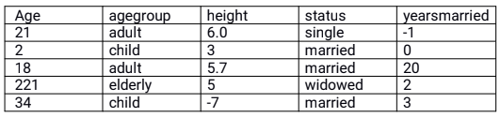
i) Read the data from the file “people.txt”.
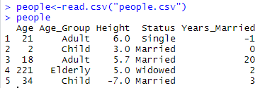
ii) Create a ruleset E that contain rules to check for the following conditions:
- The age should be in the range 0-150.
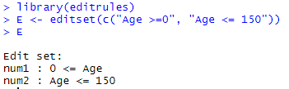
- The age should be greater than yearsmarried.
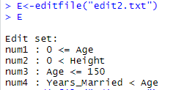
- The status should be married or single or widowed.
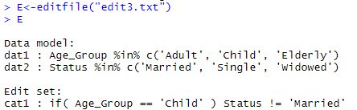
- If age is less than 18 the agegroup should be child, if age is between 18 and 65 the agegroup should be adult, if age is more than 65 the agegroup should be elderly.
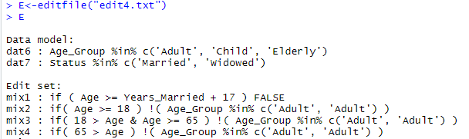
iii) Check whether ruleset E is violated by the data in the file people.txt.
1.
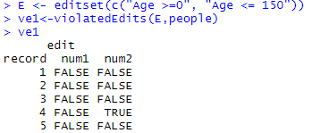
2.
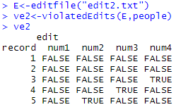

3.
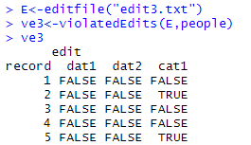
4. 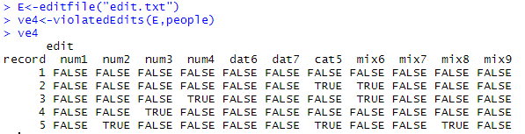
iv) Summarize the results obtained in part(iii)
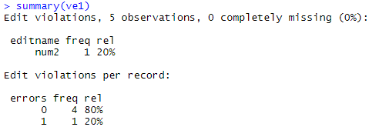
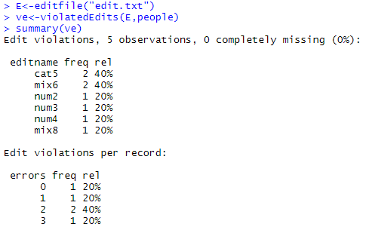
Text files used:
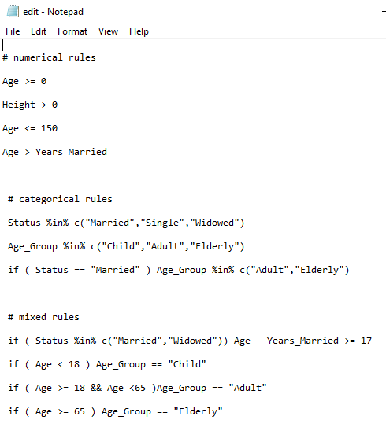
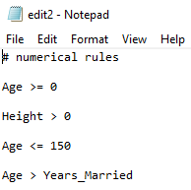
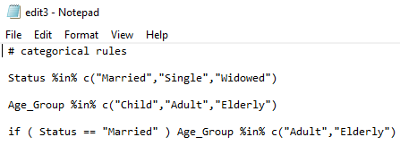
v) Visualize the results obtained in part (iii)
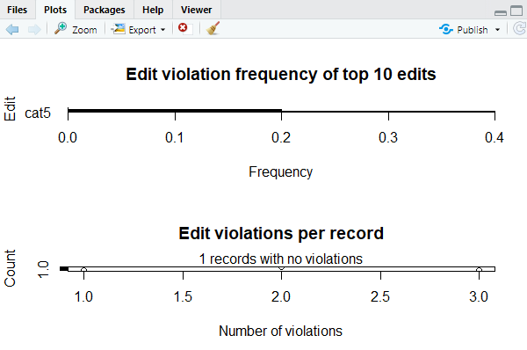
Q2. Perform the following preprocessing tasks on the dirty_iris dataset.

Sepal.Length Sepal.Width Petal.Length Petal.Width Species
1 6.4 3.2 4.500 1.5 versicolor
2 6.3 3.3 6.000 2.5 virginica
3 6.2 NaN 5.400 2.3 virginica
4 5.0 3.4 1.600 0.4 setosa
5 5.7 2.6 3.500 1.0 versicolor
6 5.3 NaN Inf 0.2 setosa
7 6.4 2.7 5.300 NaN virginica
8 5.9 3.0 5.100 1.8 virginica
9 5.8 2.7 4.100 1.0 versicolor
10 4.8 3.1 1.600 0.2 setosa
11 5.0 3.5 1.600 0.6 setosa
12 6.0 2.7 5.100 1.6 versicolor
13 6.0 3.0 4.800 Inf virginica
14 6.8 2.8 4.800 1.4 versicolor
15 NaN 3.9 1.700 0.4 setosa
16 5.0 -3.0 3.500 1.0 versicolor
17 5.5 NaN 4.000 1.3 versicolor
18 4.7 3.2 1.300 0.2 setosa
19 NaN 4.0 Inf 0.2 setosa
20 5.6 NaN 4.200 1.3 versicolor
21 4.9 3.6 NaN 0.1 setosa
22 5.4 NaN 4.500 1.5 versicolor
23 6.2 2.8 Inf 1.8 virginica
24 6.7 3.3 5.700 2.5 virginica
25 NA 3.0 5.900 2.1 virginica
26 4.6 3.2 1.400 0.2 setosa
27 4.9 3.1 1.500 0.1 setosa
28 73.0 29.0 63.000 NaN virginica
29 6.5 3.2 5.100 2.0 virginica
30 Inf 2.8 0.820 1.3 versicolor
31 4.4 3.2 NaN 0.2 setosa
32 5.9 3.2 4.800 Inf versicolor
33 5.7 2.8 4.500 1.3 versicolor
34 6.2 2.9 Inf 1.3 versicolor
35 6.6 2.9 23.000 1.3 versicolor
36 4.8 3.0 1.400 0.1 setosa
37 6.5 3.0 5.500 1.8 virginica
38 6.2 2.2 4.500 1.5 versicolor
39 6.7 2.5 5.800 1.8 virginica
40 5.0 3.0 1.600 0.2 setosa
41 5.0 Inf 1.200 0.2 setosa
42 5.8 2.7 3.900 1.2 versicolor
43 0.0 NaN 1.300 0.4 setosa
44 5.8 2.7 5.100 1.9 virginica
45 5.5 4.2 1.400 0.2 setosa
46 7.7 2.8 6.700 2.0 virginica
47 5.7 Inf NaN 0.4 setosa
48 7.0 3.2 4.700 1.4 versicolor
49 6.5 3.0 5.800 2.2 virginica
50 6.0 3.4 4.500 1.6 versicolor
51 5.5 2.6 4.400 1.2 versicolor
52 4.9 3.1 NA 0.2 setosa
53 5.2 2.7 3.900 1.4 versicolor
54 4.8 3.4 1.600 0.2 setosa
55 6.3 3.3 4.700 1.6 versicolor
56 7.7 3.8 6.700 2.2 virginica
57 5.1 3.8 1.500 0.3 setosa
58 NA 2.9 4.500 1.5 versicolor
59 6.4 2.8 5.600 NA virginica
60 6.4 2.8 5.600 2.1 virginica
61 5.0 2.3 3.300 NA versicolor
62 7.4 2.8 6.100 1.9 virginica
63 4.3 3.0 1.100 0.1 setosa
64 5.0 3.3 1.400 0.2 setosa
65 7.2 3.0 5.800 1.6 virginica
66 6.3 2.5 4.900 1.5 versicolor
67 5.1 2.5 NA 1.1 versicolor
68 NA 3.2 5.700 2.3 virginica
69 5.1 3.5 NA NA setosa
70 5.0 3.5 1.300 0.3 setosa
71 6.1 3.0 4.600 1.4 versicolor
72 6.9 3.1 5.100 2.3 virginica
73 5.1 3.5 1.400 0.3 setosa
74 6.5 NA 4.600 1.5 versicolor
75 5.6 2.8 4.900 2.0 virginica
76 4.9 2.5 4.500 NA virginica
77 5.5 3.5 1.300 0.2 setosa
78 7.6 3.0 6.600 2.1 virginica
79 5.1 3.8 0.000 0.2 setosa
80 7.9 3.8 6.400 2.0 virginica
81 6.1 2.6 5.600 1.4 virginica
82 5.4 3.4 1.700 0.2 setosa
83 6.1 2.9 4.700 1.4 versicolor
84 5.4 3.7 1.500 0.2 setosa
85 6.7 3.0 5.200 2.3 virginica
86 5.1 3.8 1.900 Inf setosa
87 6.4 2.9 4.300 1.3 versicolor
88 5.7 2.9 4.200 1.3 versicolor
89 4.4 2.9 1.400 0.2 setosa
90 6.3 2.5 5.000 1.9 virginica
91 7.2 3.2 6.000 1.8 virginica
92 4.9 NA 3.300 1.0 versicolor
93 5.2 3.4 1.400 0.2 setosa
94 5.8 2.7 5.100 1.9 virginica
95 6.0 2.2 5.000 1.5 virginica
96 6.9 3.1 NA 1.5 versicolor
97 5.5 2.3 4.000 1.3 versicolor
98 6.7 NA 5.000 1.7 versicolor
99 5.7 3.0 4.200 1.2 versicolor
100 6.3 2.8 5.100 1.5 virginica
101 5.4 3.4 1.500 0.4 setosa
102 7.2 3.6 NA 2.5 virginica
103 6.3 2.7 4.900 NA virginica
104 5.6 3.0 4.100 1.3 versicolor
105 5.1 3.7 NA 0.4 setosa
106 5.5 NA 0.925 1.0 versicolor
107 6.5 3.0 5.200 2.0 virginica
108 4.8 3.0 1.400 NA setosa
109 6.1 2.8 NA 1.3 versicolor
110 4.6 3.4 1.400 0.3 setosa
111 6.3 3.4 NA 2.4 virginica
112 5.0 3.4 1.500 0.2 setosa
113 5.1 3.4 1.500 0.2 setosa
114 NA 3.3 5.700 2.1 virginica
115 6.7 3.1 4.700 1.5 versicolor
116 7.7 2.6 6.900 2.3 virginica
117 6.3 NA 4.400 1.3 versicolor
118 4.6 3.1 1.500 0.2 setosa
119 NA 3.0 5.500 2.1 virginica
120 NA 2.8 4.700 1.2 versicolor
121 5.9 3.0 NA 1.5 versicolor
122 4.5 2.3 1.300 0.3 setosa
123 6.4 3.2 5.300 2.3 virginica
124 5.2 4.1 1.500 0.1 setosa
125 49.0 30.0 14.000 2.0 setosa
126 5.6 2.9 3.600 1.3 versicolor
127 6.8 3.2 5.900 2.3 virginica
128 5.8 NA 5.100 2.4 virginica
129 4.6 3.6 NA 0.2 setosa
130 5.7 0.0 1.700 0.3 setosa
131 5.6 2.5 3.900 1.1 versicolor
132 6.7 3.1 4.400 1.4 versicolor
133 4.8 NA 1.900 0.2 setosa
134 5.1 3.3 1.700 0.5 setosa
135 4.4 3.0 1.300 NA setosa
136 7.7 3.0 NA 2.3 virginica
137 4.7 3.2 1.600 0.2 setosa
138 NA 3.0 4.900 1.8 virginica
139 6.9 3.1 5.400 2.1 virginica
140 6.0 2.2 4.000 1.0 versicolor
141 5.0 NA 1.400 0.2 setosa
142 5.5 NA 3.800 1.1 versicolor
143 6.6 3.0 4.400 1.4 versicolor
144 6.3 2.9 5.600 1.8 virginica
145 5.7 2.5 5.000 2.0 virginica
146 6.7 3.1 5.600 2.4 virginica
147 5.6 3.0 4.500 1.5 versicolor
148 5.2 3.5 1.500 0.2 setosa
149 6.4 3.1 NA 1.8 virginica
150 5.8 2.6 4.000 NA versicolor

- Calculate the number and percentage of observations that are complete.
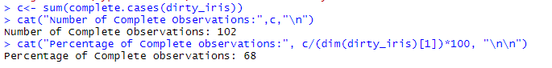
- Replace all the special values in data with NA.
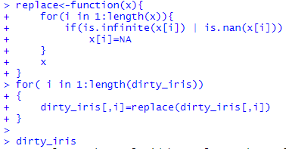
Sepal.Length Sepal.Width Petal.Length Petal.Width Species
1 6.4 3.2 4.500 1.5 versicolor
2 6.3 3.3 6.000 2.5 virginica
3 6.2 NA 5.400 2.3 virginica
4 5.0 3.4 1.600 0.4 setosa
5 5.7 2.6 3.500 1.0 versicolor
6 5.3 NA NA 0.2 setosa
7 6.4 2.7 5.300 NA virginica
8 5.9 3.0 5.100 1.8 virginica
9 5.8 2.7 4.100 1.0 versicolor
10 4.8 3.1 1.600 0.2 setosa
11 5.0 3.5 1.600 0.6 setosa
12 6.0 2.7 5.100 1.6 versicolor
13 6.0 3.0 4.800 NA virginica
14 6.8 2.8 4.800 1.4 versicolor
15 NA 3.9 1.700 0.4 setosa
16 5.0 -3.0 3.500 1.0 versicolor
17 5.5 NA 4.000 1.3 versicolor
18 4.7 3.2 1.300 0.2 setosa
19 NA 4.0 NA 0.2 setosa
20 5.6 NA 4.200 1.3 versicolor
21 4.9 3.6 NA 0.1 setosa
22 5.4 NA 4.500 1.5 versicolor
23 6.2 2.8 NA 1.8 virginica
24 6.7 3.3 5.700 2.5 virginica
25 NA 3.0 5.900 2.1 virginica
26 4.6 3.2 1.400 0.2 setosa
27 4.9 3.1 1.500 0.1 setosa
28 73.0 29.0 63.000 NA virginica
29 6.5 3.2 5.100 2.0 virginica
30 NA 2.8 0.820 1.3 versicolor
31 4.4 3.2 NA 0.2 setosa
32 5.9 3.2 4.800 NA versicolor
33 5.7 2.8 4.500 1.3 versicolor
34 6.2 2.9 NA 1.3 versicolor
35 6.6 2.9 23.000 1.3 versicolor
36 4.8 3.0 1.400 0.1 setosa
37 6.5 3.0 5.500 1.8 virginica
38 6.2 2.2 4.500 1.5 versicolor
39 6.7 2.5 5.800 1.8 virginica
40 5.0 3.0 1.600 0.2 setosa
41 5.0 NA 1.200 0.2 setosa
42 5.8 2.7 3.900 1.2 versicolor
43 0.0 NA 1.300 0.4 setosa
44 5.8 2.7 5.100 1.9 virginica
45 5.5 4.2 1.400 0.2 setosa
46 7.7 2.8 6.700 2.0 virginica
47 5.7 NA NA 0.4 setosa
48 7.0 3.2 4.700 1.4 versicolor
49 6.5 3.0 5.800 2.2 virginica
50 6.0 3.4 4.500 1.6 versicolor
51 5.5 2.6 4.400 1.2 versicolor
52 4.9 3.1 NA 0.2 setosa
53 5.2 2.7 3.900 1.4 versicolor
54 4.8 3.4 1.600 0.2 setosa
55 6.3 3.3 4.700 1.6 versicolor
56 7.7 3.8 6.700 2.2 virginica
57 5.1 3.8 1.500 0.3 setosa
58 NA 2.9 4.500 1.5 versicolor
59 6.4 2.8 5.600 NA virginica
60 6.4 2.8 5.600 2.1 virginica
61 5.0 2.3 3.300 NA versicolor
62 7.4 2.8 6.100 1.9 virginica
63 4.3 3.0 1.100 0.1 setosa
64 5.0 3.3 1.400 0.2 setosa
65 7.2 3.0 5.800 1.6 virginica
66 6.3 2.5 4.900 1.5 versicolor
67 5.1 2.5 NA 1.1 versicolor
68 NA 3.2 5.700 2.3 virginica
69 5.1 3.5 NA NA setosa
70 5.0 3.5 1.300 0.3 setosa
71 6.1 3.0 4.600 1.4 versicolor
72 6.9 3.1 5.100 2.3 virginica
73 5.1 3.5 1.400 0.3 setosa
74 6.5 NA 4.600 1.5 versicolor
75 5.6 2.8 4.900 2.0 virginica
76 4.9 2.5 4.500 NA virginica
77 5.5 3.5 1.300 0.2 setosa
78 7.6 3.0 6.600 2.1 virginica
79 5.1 3.8 0.000 0.2 setosa
80 7.9 3.8 6.400 2.0 virginica
81 6.1 2.6 5.600 1.4 virginica
82 5.4 3.4 1.700 0.2 setosa
83 6.1 2.9 4.700 1.4 versicolor
84 5.4 3.7 1.500 0.2 setosa
85 6.7 3.0 5.200 2.3 virginica
86 5.1 3.8 1.900 NA setosa
87 6.4 2.9 4.300 1.3 versicolor
88 5.7 2.9 4.200 1.3 versicolor
89 4.4 2.9 1.400 0.2 setosa
90 6.3 2.5 5.000 1.9 virginica
91 7.2 3.2 6.000 1.8 virginica
92 4.9 NA 3.300 1.0 versicolor
93 5.2 3.4 1.400 0.2 setosa
94 5.8 2.7 5.100 1.9 virginica
95 6.0 2.2 5.000 1.5 virginica
96 6.9 3.1 NA 1.5 versicolor
97 5.5 2.3 4.000 1.3 versicolor
98 6.7 NA 5.000 1.7 versicolor
99 5.7 3.0 4.200 1.2 versicolor
100 6.3 2.8 5.100 1.5 virginica
101 5.4 3.4 1.500 0.4 setosa
102 7.2 3.6 NA 2.5 virginica
103 6.3 2.7 4.900 NA virginica
104 5.6 3.0 4.100 1.3 versicolor
105 5.1 3.7 NA 0.4 setosa
106 5.5 NA 0.925 1.0 versicolor
107 6.5 3.0 5.200 2.0 virginica
108 4.8 3.0 1.400 NA setosa
109 6.1 2.8 NA 1.3 versicolor
110 4.6 3.4 1.400 0.3 setosa
111 6.3 3.4 NA 2.4 virginica
112 5.0 3.4 1.500 0.2 setosa
113 5.1 3.4 1.500 0.2 setosa
114 NA 3.3 5.700 2.1 virginica
115 6.7 3.1 4.700 1.5 versicolor
116 7.7 2.6 6.900 2.3 virginica
117 6.3 NA 4.400 1.3 versicolor
118 4.6 3.1 1.500 0.2 setosa
119 NA 3.0 5.500 2.1 virginica
120 NA 2.8 4.700 1.2 versicolor
121 5.9 3.0 NA 1.5 versicolor
122 4.5 2.3 1.300 0.3 setosa
123 6.4 3.2 5.300 2.3 virginica
124 5.2 4.1 1.500 0.1 setosa
125 49.0 30.0 14.000 2.0 setosa
126 5.6 2.9 3.600 1.3 versicolor
127 6.8 3.2 5.900 2.3 virginica
128 5.8 NA 5.100 2.4 virginica
129 4.6 3.6 NA 0.2 setosa
130 5.7 0.0 1.700 0.3 setosa
131 5.6 2.5 3.900 1.1 versicolor
132 6.7 3.1 4.400 1.4 versicolor
133 4.8 NA 1.900 0.2 setosa
134 5.1 3.3 1.700 0.5 setosa
135 4.4 3.0 1.300 NA setosa
136 7.7 3.0 NA 2.3 virginica
137 4.7 3.2 1.600 0.2 setosa
138 NA 3.0 4.900 1.8 virginica
139 6.9 3.1 5.400 2.1 virginica
140 6.0 2.2 4.000 1.0 versicolor
141 5.0 NA 1.400 0.2 setosa
142 5.5 NA 3.800 1.1 versicolor
143 6.6 3.0 4.400 1.4 versicolor
144 6.3 2.9 5.600 1.8 virginica
145 5.7 2.5 5.000 2.0 virginica
146 6.7 3.1 5.600 2.4 virginica
147 5.6 3.0 4.500 1.5 versicolor
148 5.2 3.5 1.500 0.2 setosa
149 6.4 3.1 NA 1.8 virginica
150 5.8 2.6 4.000 NA versicolor

- Define these rules in a separate text file and read them.
(Use editfile function in R (package editrules). Use similar function in Python).
Print the resulting constraint object.
–Species should be one of the following values: setosa, versicolor or virginica.
–All measured numerical properties of an iris should be positive.
–The petal length of an iris is atleast 2 times its petal width.
–The sepal length of an iris cannot exceed 30cm.
–The sepals of an iris are longer than its petals.
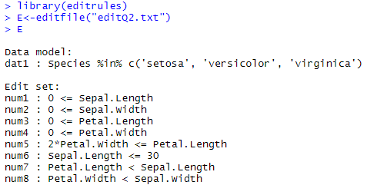
- Determine how often each rule is broken (violatedEdits). Also summarize and plot the result.
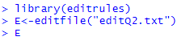
edit
record num1 num2 num3 num4 num5 num6 num7 num8 dat1
1 FALSE FALSE FALSE FALSE FALSE FALSE FALSE FALSE FALSE
2 FALSE FALSE FALSE FALSE FALSE FALSE FALSE FALSE FALSE
3 FALSE NA FALSE FALSE FALSE FALSE FALSE NA FALSE
4 FALSE FALSE FALSE FALSE FALSE FALSE FALSE FALSE FALSE
5 FALSE FALSE FALSE FALSE FALSE FALSE FALSE FALSE FALSE
6 FALSE NA NA FALSE NA FALSE NA NA FALSE
7 FALSE FALSE FALSE NA NA FALSE FALSE NA FALSE
8 FALSE FALSE FALSE FALSE FALSE FALSE FALSE FALSE FALSE
9 FALSE FALSE FALSE FALSE FALSE FALSE FALSE FALSE FALSE
10 FALSE FALSE FALSE FALSE FALSE FALSE FALSE FALSE FALSE
11 FALSE FALSE FALSE FALSE FALSE FALSE FALSE FALSE FALSE
12 FALSE FALSE FALSE FALSE FALSE FALSE FALSE FALSE FALSE
13 FALSE FALSE FALSE NA NA FALSE FALSE NA FALSE
14 FALSE FALSE FALSE FALSE FALSE FALSE FALSE FALSE FALSE
15 NA FALSE FALSE FALSE FALSE NA NA FALSE FALSE
16 FALSE TRUE FALSE FALSE FALSE FALSE FALSE TRUE FALSE
17 FALSE NA FALSE FALSE FALSE FALSE FALSE NA FALSE
18 FALSE FALSE FALSE FALSE FALSE FALSE FALSE FALSE FALSE
19 NA FALSE NA FALSE NA NA NA FALSE FALSE
20 FALSE NA FALSE FALSE FALSE FALSE FALSE NA FALSE
21 FALSE FALSE NA FALSE NA FALSE NA FALSE FALSE
22 FALSE NA FALSE FALSE FALSE FALSE FALSE NA FALSE
23 FALSE FALSE NA FALSE NA FALSE NA FALSE FALSE
24 FALSE FALSE FALSE FALSE FALSE FALSE FALSE FALSE FALSE
25 NA FALSE FALSE FALSE FALSE NA NA FALSE FALSE
26 FALSE FALSE FALSE FALSE FALSE FALSE FALSE FALSE FALSE
27 FALSE FALSE FALSE FALSE FALSE FALSE FALSE FALSE FALSE
28 FALSE FALSE FALSE NA NA TRUE FALSE NA FALSE
29 FALSE FALSE FALSE FALSE FALSE FALSE FALSE FALSE FALSE
30 NA FALSE FALSE FALSE TRUE NA NA FALSE FALSE
31 FALSE FALSE NA FALSE NA FALSE NA FALSE FALSE
32 FALSE FALSE FALSE NA NA FALSE FALSE NA FALSE
33 FALSE FALSE FALSE FALSE FALSE FALSE FALSE FALSE FALSE
34 FALSE FALSE NA FALSE NA FALSE NA FALSE FALSE
35 FALSE FALSE FALSE FALSE FALSE FALSE TRUE FALSE FALSE
36 FALSE FALSE FALSE FALSE FALSE FALSE FALSE FALSE FALSE
37 FALSE FALSE FALSE FALSE FALSE FALSE FALSE FALSE FALSE
38 FALSE FALSE FALSE FALSE FALSE FALSE FALSE FALSE FALSE
39 FALSE FALSE FALSE FALSE FALSE FALSE FALSE FALSE FALSE
40 FALSE FALSE FALSE FALSE FALSE FALSE FALSE FALSE FALSE
41 FALSE NA FALSE FALSE FALSE FALSE FALSE NA FALSE
42 FALSE FALSE FALSE FALSE FALSE FALSE FALSE FALSE FALSE
43 FALSE NA FALSE FALSE FALSE FALSE TRUE NA FALSE
44 FALSE FALSE FALSE FALSE FALSE FALSE FALSE FALSE FALSE
45 FALSE FALSE FALSE FALSE FALSE FALSE FALSE FALSE FALSE
46 FALSE FALSE FALSE FALSE FALSE FALSE FALSE FALSE FALSE
47 FALSE NA NA FALSE NA FALSE NA NA FALSE
48 FALSE FALSE FALSE FALSE FALSE FALSE FALSE FALSE FALSE
49 FALSE FALSE FALSE FALSE FALSE FALSE FALSE FALSE FALSE
50 FALSE FALSE FALSE FALSE FALSE FALSE FALSE FALSE FALSE
51 FALSE FALSE FALSE FALSE FALSE FALSE FALSE FALSE FALSE
52 FALSE FALSE NA FALSE NA FALSE NA FALSE FALSE
53 FALSE FALSE FALSE FALSE FALSE FALSE FALSE FALSE FALSE
54 FALSE FALSE FALSE FALSE FALSE FALSE FALSE FALSE FALSE
55 FALSE FALSE FALSE FALSE FALSE FALSE FALSE FALSE FALSE
56 FALSE FALSE FALSE FALSE FALSE FALSE FALSE FALSE FALSE
57 FALSE FALSE FALSE FALSE FALSE FALSE FALSE FALSE FALSE
58 NA FALSE FALSE FALSE FALSE NA NA FALSE FALSE
59 FALSE FALSE FALSE NA NA FALSE FALSE NA FALSE
60 FALSE FALSE FALSE FALSE FALSE FALSE FALSE FALSE FALSE
61 FALSE FALSE FALSE NA NA FALSE FALSE NA FALSE
62 FALSE FALSE FALSE FALSE FALSE FALSE FALSE FALSE FALSE
63 FALSE FALSE FALSE FALSE FALSE FALSE FALSE FALSE FALSE
64 FALSE FALSE FALSE FALSE FALSE FALSE FALSE FALSE FALSE
65 FALSE FALSE FALSE FALSE FALSE FALSE FALSE FALSE FALSE
66 FALSE FALSE FALSE FALSE FALSE FALSE FALSE FALSE FALSE
67 FALSE FALSE NA FALSE NA FALSE NA FALSE FALSE
68 NA FALSE FALSE FALSE FALSE NA NA FALSE FALSE
69 FALSE FALSE NA NA NA FALSE NA NA FALSE
70 FALSE FALSE FALSE FALSE FALSE FALSE FALSE FALSE FALSE
71 FALSE FALSE FALSE FALSE FALSE FALSE FALSE FALSE FALSE
72 FALSE FALSE FALSE FALSE FALSE FALSE FALSE FALSE FALSE
73 FALSE FALSE FALSE FALSE FALSE FALSE FALSE FALSE FALSE
74 FALSE NA FALSE FALSE FALSE FALSE FALSE NA FALSE
75 FALSE FALSE FALSE FALSE FALSE FALSE FALSE FALSE FALSE
76 FALSE FALSE FALSE NA NA FALSE FALSE NA FALSE
77 FALSE FALSE FALSE FALSE FALSE FALSE FALSE FALSE FALSE
78 FALSE FALSE FALSE FALSE FALSE FALSE FALSE FALSE FALSE
79 FALSE FALSE FALSE FALSE TRUE FALSE FALSE FALSE FALSE
80 FALSE FALSE FALSE FALSE FALSE FALSE FALSE FALSE FALSE
81 FALSE FALSE FALSE FALSE FALSE FALSE FALSE FALSE FALSE
82 FALSE FALSE FALSE FALSE FALSE FALSE FALSE FALSE FALSE
83 FALSE FALSE FALSE FALSE FALSE FALSE FALSE FALSE FALSE
84 FALSE FALSE FALSE FALSE FALSE FALSE FALSE FALSE FALSE
85 FALSE FALSE FALSE FALSE FALSE FALSE FALSE FALSE FALSE
86 FALSE FALSE FALSE NA NA FALSE FALSE NA FALSE
87 FALSE FALSE FALSE FALSE FALSE FALSE FALSE FALSE FALSE
88 FALSE FALSE FALSE FALSE FALSE FALSE FALSE FALSE FALSE
89 FALSE FALSE FALSE FALSE FALSE FALSE FALSE FALSE FALSE
90 FALSE FALSE FALSE FALSE FALSE FALSE FALSE FALSE FALSE
91 FALSE FALSE FALSE FALSE FALSE FALSE FALSE FALSE FALSE
92 FALSE NA FALSE FALSE FALSE FALSE FALSE NA FALSE
93 FALSE FALSE FALSE FALSE FALSE FALSE FALSE FALSE FALSE
94 FALSE FALSE FALSE FALSE FALSE FALSE FALSE FALSE FALSE
95 FALSE FALSE FALSE FALSE FALSE FALSE FALSE FALSE FALSE
96 FALSE FALSE NA FALSE NA FALSE NA FALSE FALSE
97 FALSE FALSE FALSE FALSE FALSE FALSE FALSE FALSE FALSE
98 FALSE NA FALSE FALSE FALSE FALSE FALSE NA FALSE
99 FALSE FALSE FALSE FALSE FALSE FALSE FALSE FALSE FALSE
100 FALSE FALSE FALSE FALSE FALSE FALSE FALSE FALSE FALSE
101 FALSE FALSE FALSE FALSE FALSE FALSE FALSE FALSE FALSE
102 FALSE FALSE NA FALSE NA FALSE NA FALSE FALSE
103 FALSE FALSE FALSE NA NA FALSE FALSE NA FALSE
104 FALSE FALSE FALSE FALSE FALSE FALSE FALSE FALSE FALSE
105 FALSE FALSE NA FALSE NA FALSE NA FALSE FALSE
106 FALSE NA FALSE FALSE TRUE FALSE FALSE NA FALSE
107 FALSE FALSE FALSE FALSE FALSE FALSE FALSE FALSE FALSE
108 FALSE FALSE FALSE NA NA FALSE FALSE NA FALSE
109 FALSE FALSE NA FALSE NA FALSE NA FALSE FALSE
110 FALSE FALSE FALSE FALSE FALSE FALSE FALSE FALSE FALSE
111 FALSE FALSE NA FALSE NA FALSE NA FALSE FALSE
[ reached getOption("max.print") -- omitted 39 rows ]

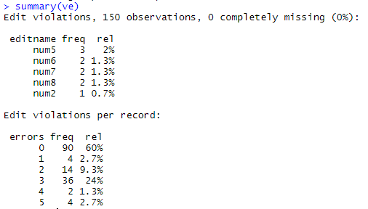
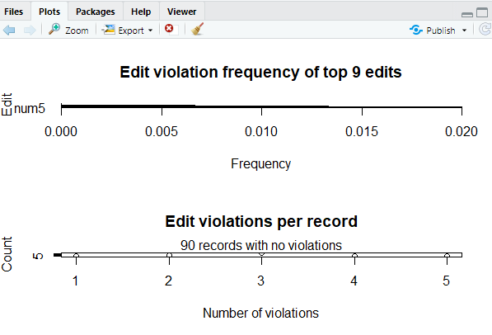
- Find outliers in sepal length using boxplot and boxplot.stats
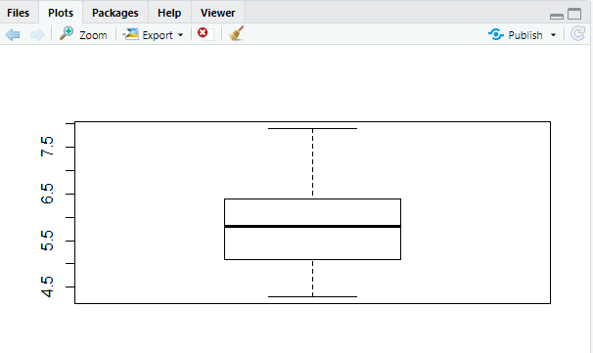
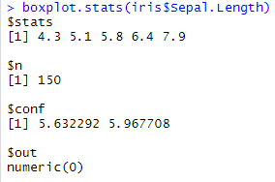

Text file used:
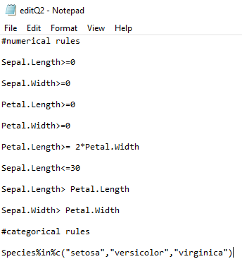
Q3. Load the data from wine dataset. Check whether all attributes are standardized or not (mean is 0 and standard deviation is 1). If not, standardize the attributes. Do the same with Iris dataset.
> wine
Category Alcohol Malic acid Ash Alcalinity of ash Magnesium Total phenols
1 1 14.23 1.71 2.43 15.6 127 2.80
2 1 13.20 1.78 2.14 11.2 100 2.65
3 1 13.16 2.36 2.67 18.6 101 2.80
4 1 14.37 1.95 2.50 16.8 113 3.85
5 1 13.24 2.59 2.87 21.0 118 2.80
6 1 14.20 1.76 2.45 15.2 112 3.27
7 1 14.39 1.87 2.45 14.6 96 2.50
8 1 14.06 2.15 2.61 17.6 121 2.60
9 1 14.83 1.64 2.17 14.0 97 2.80
10 1 13.86 1.35 2.27 16.0 98 2.98
11 1 14.10 2.16 2.30 18.0 105 2.95
12 1 14.12 1.48 2.32 16.8 95 2.20
13 1 13.75 1.73 2.41 16.0 89 2.60
14 1 14.75 1.73 2.39 11.4 91 3.10
15 1 14.38 1.87 2.38 12.0 102 3.30
16 1 13.63 1.81 2.70 17.2 112 2.85
17 1 14.30 1.92 2.72 20.0 120 2.80
18 1 13.83 1.57 2.62 20.0 115 2.95
19 1 14.19 1.59 2.48 16.5 108 3.30
20 1 13.64 3.10 2.56 15.2 116 2.70
21 1 14.06 1.63 2.28 16.0 126 3.00
22 1 12.93 3.80 2.65 18.6 102 2.41
23 1 13.71 1.86 2.36 16.6 101 2.61
24 1 12.85 1.60 2.52 17.8 95 2.48
25 1 13.50 1.81 2.61 20.0 96 2.53
26 1 13.05 2.05 3.22 25.0 124 2.63
27 1 13.39 1.77 2.62 16.1 93 2.85
28 1 13.30 1.72 2.14 17.0 94 2.40
29 1 13.87 1.90 2.80 19.4 107 2.95
30 1 14.02 1.68 2.21 16.0 96 2.65
31 1 13.73 1.50 2.70 22.5 101 3.00
32 1 13.58 1.66 2.36 19.1 106 2.86
33 1 13.68 1.83 2.36 17.2 104 2.42
34 1 13.76 1.53 2.70 19.5 132 2.95
35 1 13.51 1.80 2.65 19.0 110 2.35
36 1 13.48 1.81 2.41 20.5 100 2.70
37 1 13.28 1.64 2.84 15.5 110 2.60
38 1 13.05 1.65 2.55 18.0 98 2.45
39 1 13.07 1.50 2.10 15.5 98 2.40
40 1 14.22 3.99 2.51 13.2 128 3.00
41 1 13.56 1.71 2.31 16.2 117 3.15
42 1 13.41 3.84 2.12 18.8 90 2.45
43 1 13.88 1.89 2.59 15.0 101 3.25
44 1 13.24 3.98 2.29 17.5 103 2.64
45 1 13.05 1.77 2.10 17.0 107 3.00
46 1 14.21 4.04 2.44 18.9 111 2.85
47 1 14.38 3.59 2.28 16.0 102 3.25
48 1 13.90 1.68 2.12 16.0 101 3.10
49 1 14.10 2.02 2.40 18.8 103 2.75
50 1 13.94 1.73 2.27 17.4 108 2.88
51 1 13.05 1.73 2.04 12.4 92 2.72
52 1 13.83 1.65 2.60 17.2 94 2.45
53 1 13.82 1.75 2.42 14.0 111 3.88
54 1 13.77 1.90 2.68 17.1 115 3.00
55 1 13.74 1.67 2.25 16.4 118 2.60
56 1 13.56 1.73 2.46 20.5 116 2.96
57 1 14.22 1.70 2.30 16.3 118 3.20
58 1 13.29 1.97 2.68 16.8 102 3.00
59 1 13.72 1.43 2.50 16.7 108 3.40
60 2 12.37 0.94 1.36 10.6 88 1.98
61 2 12.33 1.10 2.28 16.0 101 2.05
62 2 12.64 1.36 2.02 16.8 100 2.02
63 2 13.67 1.25 1.92 18.0 94 2.10
64 2 12.37 1.13 2.16 19.0 87 3.50
65 2 12.17 1.45 2.53 19.0 104 1.89
66 2 12.37 1.21 2.56 18.1 98 2.42
67 2 13.11 1.01 1.70 15.0 78 2.98
68 2 12.37 1.17 1.92 19.6 78 2.11
69 2 13.34 0.94 2.36 17.0 110 2.53
70 2 12.21 1.19 1.75 16.8 151 1.85
71 2 12.29 1.61 2.21 20.4 103 1.10
Flavanoids Nonflavanoid phenols Proanthocyanins Color intensity Hue
1 3.06 0.28 2.29 5.64 1.040
2 2.76 0.26 1.28 4.38 1.050
3 3.24 0.30 2.81 5.68 1.030
4 3.49 0.24 2.18 7.80 0.860
5 2.69 0.39 1.82 4.32 1.040
6 3.39 0.34 1.97 6.75 1.050
7 2.52 0.30 1.98 5.25 1.020
8 2.51 0.31 1.25 5.05 1.060
9 2.98 0.29 1.98 5.20 1.080
10 3.15 0.22 1.85 7.22 1.010
11 3.32 0.22 2.38 5.75 1.250
12 2.43 0.26 1.57 5.00 1.170
13 2.76 0.29 1.81 5.60 1.150
14 3.69 0.43 2.81 5.40 1.250
15 3.64 0.29 2.96 7.50 1.200
16 2.91 0.30 1.46 7.30 1.280
17 3.14 0.33 1.97 6.20 1.070
18 3.40 0.40 1.72 6.60 1.130
19 3.93 0.32 1.86 8.70 1.230
20 3.03 0.17 1.66 5.10 0.960
21 3.17 0.24 2.10 5.65 1.090
22 2.41 0.25 1.98 4.50 1.030
23 2.88 0.27 1.69 3.80 1.110
24 2.37 0.26 1.46 3.93 1.090
25 2.61 0.28 1.66 3.52 1.120
26 2.68 0.47 1.92 3.58 1.130
27 2.94 0.34 1.45 4.80 0.920
28 2.19 0.27 1.35 3.95 1.020
29 2.97 0.37 1.76 4.50 1.250
30 2.33 0.26 1.98 4.70 1.040
31 3.25 0.29 2.38 5.70 1.190
32 3.19 0.22 1.95 6.90 1.090
33 2.69 0.42 1.97 3.84 1.230
34 2.74 0.50 1.35 5.40 1.250
35 2.53 0.29 1.54 4.20 1.100
36 2.98 0.26 1.86 5.10 1.040
37 2.68 0.34 1.36 4.60 1.090
38 2.43 0.29 1.44 4.25 1.120
39 2.64 0.28 1.37 3.70 1.180
40 3.04 0.20 2.08 5.10 0.890
41 3.29 0.34 2.34 6.13 0.950
42 2.68 0.27 1.48 4.28 0.910
43 3.56 0.17 1.70 5.43 0.880
44 2.63 0.32 1.66 4.36 0.820
45 3.00 0.28 2.03 5.04 0.880
46 2.65 0.30 1.25 5.24 0.870
47 3.17 0.27 2.19 4.90 1.040
48 3.39 0.21 2.14 6.10 0.910
49 2.92 0.32 2.38 6.20 1.070
50 3.54 0.32 2.08 8.90 1.120
51 3.27 0.17 2.91 7.20 1.120
52 2.99 0.22 2.29 5.60 1.240
53 3.74 0.32 1.87 7.05 1.010
54 2.79 0.39 1.68 6.30 1.130
55 2.90 0.21 1.62 5.85 0.920
56 2.78 0.20 2.45 6.25 0.980
57 3.00 0.26 2.03 6.38 0.940
58 3.23 0.31 1.66 6.00 1.070
59 3.67 0.19 2.04 6.80 0.890
60 0.57 0.28 0.42 1.95 1.050
61 1.09 0.63 0.41 3.27 1.250
62 1.41 0.53 0.62 5.75 0.980
63 1.79 0.32 0.73 3.80 1.230
64 3.10 0.19 1.87 4.45 1.220
65 1.75 0.45 1.03 2.95 1.450
66 2.65 0.37 2.08 4.60 1.190
67 3.18 0.26 2.28 5.30 1.120
68 2.00 0.27 1.04 4.68 1.120
69 1.30 0.55 0.42 3.17 1.020
70 1.28 0.14 2.50 2.85 1.280
71 1.02 0.37 1.46 3.05 0.906
OD280/OD315 of diluted wines Proline
1 3.92 1065
2 3.40 1050
3 3.17 1185
4 3.45 1480
5 2.93 735
6 2.85 1450
7 3.58 1290
8 3.58 1295
9 2.85 1045
10 3.55 1045
11 3.17 1510
12 2.82 1280
13 2.90 1320
14 2.73 1150
15 3.00 1547
16 2.88 1310
17 2.65 1280
18 2.57 1130
19 2.82 1680
20 3.36 845
21 3.71 780
22 3.52 770
23 4.00 1035
24 3.63 1015
25 3.82 845
26 3.20 830
27 3.22 1195
28 2.77 1285
29 3.40 915
30 3.59 1035
31 2.71 1285
32 2.88 1515
33 2.87 990
34 3.00 1235
35 2.87 1095
36 3.47 920
37 2.78 880
38 2.51 1105
39 2.69 1020
40 3.53 760
41 3.38 795
42 3.00 1035
43 3.56 1095
44 3.00 680
45 3.35 885
46 3.33 1080
47 3.44 1065
48 3.33 985
49 2.75 1060
50 3.10 1260
51 2.91 1150
52 3.37 1265
53 3.26 1190
54 2.93 1375
55 3.20 1060
56 3.03 1120
57 3.31 970
58 2.84 1270
59 2.87 1285
60 1.82 520
61 1.67 680
62 1.59 450
63 2.46 630
64 2.87 420
65 2.23 355
66 2.30 678
67 3.18 502
68 3.48 510
69 1.93 750
70 3.07 718
71 1.82 870
[ reached 'max' / getOption("max.print") -- omitted 107 rows ]

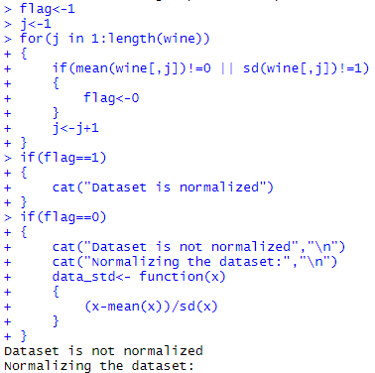
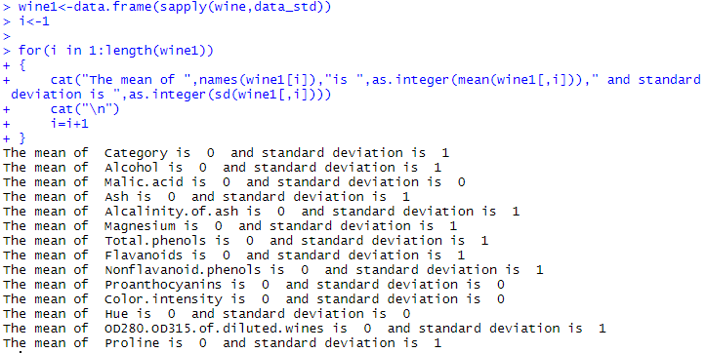

Q4. Run Apriori algorithm to find frequent item sets and association rules
4.1 Use minimum support as 50% and minimum confidence as 75%
4.2 Use minimum support as 60% and minimum confidence as 60%
> library(arules)
Loading required package: Matrix

Attaching package: ‘arules’

The following objects are masked from ‘package:base’:

abbreviate, write

> library(datasets)
> data("Groceries")
> inspect(Groceries[1:10])
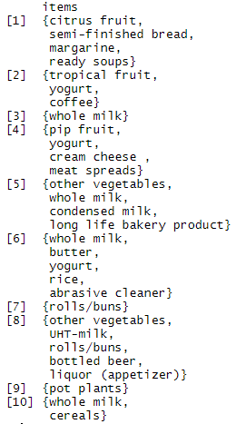
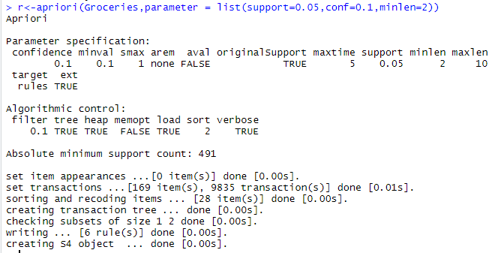
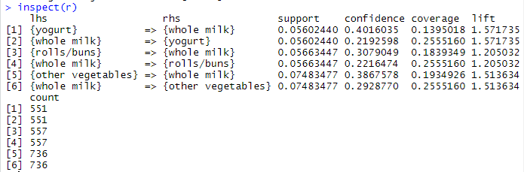
> bakery<- read.transactions("1000-out1.csv")
> inspect(bakery)
> bakery
> r<-apriori(bakery,parameter = list(support=0.04,conf=0.3,minlen=2))
> inspect(r)
> bakery<-read.transactions("1000i.csv")
> inspect(bakery)
> bakery
> r<-apriori(bakery,parameter = list(support=0.0005,conf=0.1,minlen=2))
> inspect(r)
> data("Adult")
> inspect(Adult[1:10])
items transactionID
[1] {age=Middle-aged,
workclass=State-gov,
education=Bachelors,
marital-status=Never-married,
occupation=Adm-clerical,
relationship=Not-in-family,
race=White,
sex=Male,
capital-gain=Low,
capital-loss=None,
hours-per-week=Full-time,
native-country=United-States,
income=small} 1
[2] {age=Senior,
workclass=Self-emp-not-inc,
education=Bachelors,
marital-status=Married-civ-spouse,
occupation=Exec-managerial,
relationship=Husband,
race=White,
sex=Male,
capital-gain=None,
capital-loss=None,
hours-per-week=Part-time,
native-country=United-States,
income=small} 2
[3] {age=Middle-aged,
workclass=Private,
education=HS-grad,
marital-status=Divorced,
occupation=Handlers-cleaners,
relationship=Not-in-family,
race=White,
sex=Male,
capital-gain=None,
capital-loss=None,
hours-per-week=Full-time,
native-country=United-States,
income=small} 3
[4] {age=Senior,
workclass=Private,
education=11th,
marital-status=Married-civ-spouse,
occupation=Handlers-cleaners,
relationship=Husband,
race=Black,
sex=Male,
capital-gain=None,
capital-loss=None,
hours-per-week=Full-time,
native-country=United-States,
income=small} 4
[5] {age=Middle-aged,
workclass=Private,
education=Bachelors,
marital-status=Married-civ-spouse,
occupation=Prof-specialty,
relationship=Wife,
race=Black,
sex=Female,
capital-gain=None,
capital-loss=None,
hours-per-week=Full-time,
native-country=Cuba,
income=small} 5
[6] {age=Middle-aged,
workclass=Private,
education=Masters,
marital-status=Married-civ-spouse,
occupation=Exec-managerial,
relationship=Wife,
race=White,
sex=Female,
capital-gain=None,
capital-loss=None,
hours-per-week=Full-time,
native-country=United-States,
income=small} 6
[7] {age=Senior,
workclass=Private,
education=9th,
marital-status=Married-spouse-absent,
occupation=Other-service,
relationship=Not-in-family,
race=Black,
sex=Female,
capital-gain=None,
capital-loss=None,
hours-per-week=Part-time,
native-country=Jamaica,
income=small} 7
[8] {age=Senior,
workclass=Self-emp-not-inc,
education=HS-grad,
marital-status=Married-civ-spouse,
occupation=Exec-managerial,
relationship=Husband,
race=White,
sex=Male,
capital-gain=None,
capital-loss=None,
hours-per-week=Over-time,
native-country=United-States,
income=large} 8
[9] {age=Middle-aged,
workclass=Private,
education=Masters,
marital-status=Never-married,
occupation=Prof-specialty,
relationship=Not-in-family,
race=White,
sex=Female,
capital-gain=High,
capital-loss=None,
hours-per-week=Over-time,
native-country=United-States,
income=large} 9
[10] {age=Middle-aged,
workclass=Private,
education=Bachelors,
marital-status=Married-civ-spouse,
occupation=Exec-managerial,
relationship=Husband,
race=White,
sex=Male,
capital-gain=Low,
capital-loss=None,
hours-per-week=Full-time,
native-country=United-States,
income=large} 10
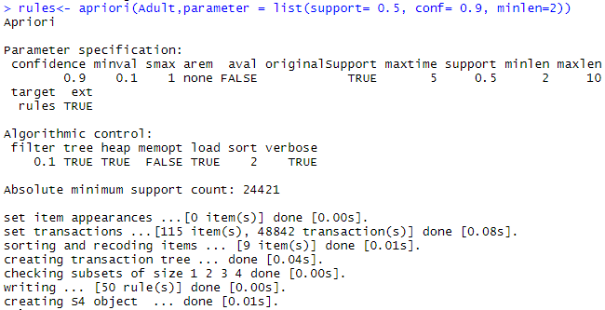
> inspect(rules)
lhs rhs support confidence coverage lift count
[1] {hours-per-week=Full-time} => {capital-gain=None} 0.5435895 0.9290688 0.5850907 1.0127342 26550
[2] {hours-per-week=Full-time} => {capital-loss=None} 0.5606650 0.9582531 0.5850907 1.0052191 27384
[3] {sex=Male} => {capital-gain=None} 0.6050735 0.9051455 0.6684820 0.9866565 29553
[4] {sex=Male} => {capital-loss=None} 0.6331027 0.9470750 0.6684820 0.9934931 30922
[5] {workclass=Private} => {capital-gain=None} 0.6413742 0.9239073 0.6941976 1.0071078 31326
[6] {workclass=Private} => {capital-loss=None} 0.6639982 0.9564974 0.6941976 1.0033773 32431
[7] {race=White} => {native-country=United-States} 0.7881127 0.9217231 0.8550428 1.0270761 38493
[8] {race=White} => {capital-gain=None} 0.7817862 0.9143240 0.8550428 0.9966616 38184
[9] {race=White} => {capital-loss=None} 0.8136849 0.9516307 0.8550428 0.9982720 39742
[10] {native-country=United-States} => {capital-gain=None} 0.8219565 0.9159062 0.8974243 0.9983862 40146
[11] {native-country=United-States} => {capital-loss=None} 0.8548380 0.9525461 0.8974243 0.9992323 41752
[12] {capital-gain=None} => {capital-loss=None} 0.8706646 0.9490705 0.9173867 0.9955863 42525
[13] {capital-loss=None} => {capital-gain=None} 0.8706646 0.9133376 0.9532779 0.9955863 42525
[14] {capital-gain=None,
hours-per-week=Full-time} => {capital-loss=None} 0.5191638 0.9550659 0.5435895 1.0018756 25357
[15] {capital-loss=None,
hours-per-week=Full-time} => {capital-gain=None} 0.5191638 0.9259787 0.5606650 1.0093657 25357
[16] {race=White,
sex=Male} => {native-country=United-States} 0.5415421 0.9204803 0.5883256 1.0256912 26450
[17] {sex=Male,
native-country=United-States} => {race=White} 0.5415421 0.9051090 0.5983170 1.0585540 26450
[18] {race=White,
sex=Male} => {capital-gain=None} 0.5313050 0.9030799 0.5883256 0.9844048 25950
[19] {race=White,
sex=Male} => {capital-loss=None} 0.5564268 0.9457804 0.5883256 0.9921350 27177
[20] {sex=Male,
native-country=United-States} => {capital-gain=None} 0.5406003 0.9035349 0.5983170 0.9849008 26404
[21] {sex=Male,
native-country=United-States} => {capital-loss=None} 0.5661316 0.9462068 0.5983170 0.9925823 27651
[22] {sex=Male,
capital-gain=None} => {capital-loss=None} 0.5696941 0.9415288 0.6050735 0.9876750 27825
[23] {workclass=Private,
race=White} => {native-country=United-States} 0.5433848 0.9144157 0.5942427 1.0189334 26540
[24] {workclass=Private,
race=White} => {capital-gain=None} 0.5472339 0.9208931 0.5942427 1.0038221 26728
[25] {workclass=Private,
race=White} => {capital-loss=None} 0.5674829 0.9549683 0.5942427 1.0017732 27717
[26] {workclass=Private,
native-country=United-States} => {capital-gain=None} 0.5689570 0.9218444 0.6171942 1.0048592 27789
[27] {workclass=Private,
native-country=United-States} => {capital-loss=None} 0.5897179 0.9554818 0.6171942 1.0023119 28803
[28] {workclass=Private,
capital-gain=None} => {capital-loss=None} 0.6111748 0.9529145 0.6413742 0.9996188 29851
[29] {workclass=Private,
capital-loss=None} => {capital-gain=None} 0.6111748 0.9204465 0.6639982 1.0033354 29851
[30] {race=White,
native-country=United-States} => {capital-gain=None} 0.7194628 0.9128933 0.7881127 0.9951019 35140
[31] {race=White,
capital-gain=None} => {native-country=United-States} 0.7194628 0.9202807 0.7817862 1.0254689 35140
[32] {race=White,
native-country=United-States} => {capital-loss=None} 0.7490480 0.9504325 0.7881127 0.9970152 36585
[33] {race=White,
capital-loss=None} => {native-country=United-States} 0.7490480 0.9205626 0.8136849 1.0257830 36585
[34] {race=White,
capital-gain=None} => {capital-loss=None} 0.7404283 0.9470983 0.7817862 0.9935175 36164
[35] {race=White,
capital-loss=None} => {capital-gain=None} 0.7404283 0.9099693 0.8136849 0.9919147 36164
[36] {capital-gain=None,
native-country=United-States} => {capital-loss=None} 0.7793702 0.9481891 0.8219565 0.9946618 38066
[37] {capital-loss=None,
native-country=United-States} => {capital-gain=None} 0.7793702 0.9117168 0.8548380 0.9938195 38066
[38] {race=White,
sex=Male,
native-country=United-States} => {capital-loss=None} 0.5113632 0.9442722 0.5415421 0.9905529 24976
[39] {race=White,
sex=Male,
capital-loss=None} => {native-country=United-States} 0.5113632 0.9190124 0.5564268 1.0240556 24976
[40] {sex=Male,
capital-loss=None,
native-country=United-States} => {race=White} 0.5113632 0.9032585 0.5661316 1.0563898 24976
[41] {sex=Male,
capital-gain=None,
native-country=United-States} => {capital-loss=None} 0.5084149 0.9404636 0.5406003 0.9865576 24832
[42] {workclass=Private,
race=White,
native-country=United-States} => {capital-loss=None} 0.5181401 0.9535418 0.5433848 1.0002768 25307
[43] {workclass=Private,
race=White,
capital-loss=None} => {native-country=United-States} 0.5181401 0.9130498 0.5674829 1.0174114 25307
[44] {workclass=Private,
race=White,
capital-gain=None} => {capital-loss=None} 0.5204742 0.9511000 0.5472339 0.9977153 25421
[45] {workclass=Private,
race=White,
capital-loss=None} => {capital-gain=None} 0.5204742 0.9171628 0.5674829 0.9997559 25421
[46] {workclass=Private,
capital-gain=None,
native-country=United-States} => {capital-loss=None} 0.5414807 0.9517075 0.5689570 0.9983526 26447
[47] {workclass=Private,
capital-loss=None,
native-country=United-States} => {capital-gain=None} 0.5414807 0.9182030 0.5897179 1.0008898 26447
[48] {race=White,
capital-gain=None,
native-country=United-States} => {capital-loss=None} 0.6803980 0.9457029 0.7194628 0.9920537 33232
[49] {race=White,
capital-loss=None,
native-country=United-States} => {capital-gain=None} 0.6803980 0.9083504 0.7490480 0.9901500 33232
[50] {race=White,
capital-gain=None,
capital-loss=None} => {native-country=United-States} 0.6803980 0.9189249 0.7404283 1.0239581 33232

Q5. Use Naive bayes, K-nearest, and Decision tree classification algorithms and build classifiers. Divide the dataset into training and test set. Compare the accuracy of the different classifiers under the following situations:
5.1 a) Training set=75% Test set= 25% b) Training set = 66.6% ( 2/3rd of total), Test set = 33.3%
5.2 Training set is chosen by i) holdout method ii) Random subsampling iii) Cross-Validation. Compare the accuracy of the classifiers obtained.
5.3 Data is scaled to standard format.

Naive Bayes
library(caret)
library(klaR)
library(rpart)
library(rpart.plot)
library(class)
library(plyr)
i)Training set 75%
s<-createDataPartition(iris$Species,p = 0.75,list=F)
iris_train<- iris[s,]
iris_train
## Sepal.Length Sepal.Width Petal.Length Petal.Width Species
## 1 5.1 3.5 1.4 0.2 setosa
## 2 4.9 3.0 1.4 0.2 setosa
## 3 4.7 3.2 1.3 0.2 setosa
## 4 4.6 3.1 1.5 0.2 setosa
## 5 5.0 3.6 1.4 0.2 setosa
## 6 5.4 3.9 1.7 0.4 setosa
## 8 5.0 3.4 1.5 0.2 setosa
## 9 4.4 2.9 1.4 0.2 setosa
## 11 5.4 3.7 1.5 0.2 setosa
## 12 4.8 3.4 1.6 0.2 setosa
## 16 5.7 4.4 1.5 0.4 setosa
## 17 5.4 3.9 1.3 0.4 setosa
## 19 5.7 3.8 1.7 0.3 setosa
## 20 5.1 3.8 1.5 0.3 setosa
## 23 4.6 3.6 1.0 0.2 setosa
## 24 5.1 3.3 1.7 0.5 setosa
## 25 4.8 3.4 1.9 0.2 setosa
## 26 5.0 3.0 1.6 0.2 setosa
## 27 5.0 3.4 1.6 0.4 setosa
## 28 5.2 3.5 1.5 0.2 setosa
## 29 5.2 3.4 1.4 0.2 setosa
## 30 4.7 3.2 1.6 0.2 setosa
## 31 4.8 3.1 1.6 0.2 setosa
## 32 5.4 3.4 1.5 0.4 setosa
## 33 5.2 4.1 1.5 0.1 setosa
## 34 5.5 4.2 1.4 0.2 setosa
## 35 4.9 3.1 1.5 0.2 setosa
## 37 5.5 3.5 1.3 0.2 setosa
## 38 4.9 3.6 1.4 0.1 setosa
## 39 4.4 3.0 1.3 0.2 setosa
## 40 5.1 3.4 1.5 0.2 setosa
## 41 5.0 3.5 1.3 0.3 setosa
## 43 4.4 3.2 1.3 0.2 setosa
## 45 5.1 3.8 1.9 0.4 setosa
## 46 4.8 3.0 1.4 0.3 setosa
## 48 4.6 3.2 1.4 0.2 setosa
## 49 5.3 3.7 1.5 0.2 setosa
## 50 5.0 3.3 1.4 0.2 setosa
## 51 7.0 3.2 4.7 1.4 versicolor
## 53 6.9 3.1 4.9 1.5 versicolor
## 54 5.5 2.3 4.0 1.3 versicolor
## 55 6.5 2.8 4.6 1.5 versicolor
## 56 5.7 2.8 4.5 1.3 versicolor
## 58 4.9 2.4 3.3 1.0 versicolor
## 59 6.6 2.9 4.6 1.3 versicolor
## 60 5.2 2.7 3.9 1.4 versicolor
## 61 5.0 2.0 3.5 1.0 versicolor
## 62 5.9 3.0 4.2 1.5 versicolor
## 63 6.0 2.2 4.0 1.0 versicolor
## 64 6.1 2.9 4.7 1.4 versicolor
## 65 5.6 2.9 3.6 1.3 versicolor
## 66 6.7 3.1 4.4 1.4 versicolor
## 67 5.6 3.0 4.5 1.5 versicolor
## 68 5.8 2.7 4.1 1.0 versicolor
## 69 6.2 2.2 4.5 1.5 versicolor
## 70 5.6 2.5 3.9 1.1 versicolor
## 71 5.9 3.2 4.8 1.8 versicolor
## 73 6.3 2.5 4.9 1.5 versicolor
## 75 6.4 2.9 4.3 1.3 versicolor
## 76 6.6 3.0 4.4 1.4 versicolor
## 77 6.8 2.8 4.8 1.4 versicolor
## 79 6.0 2.9 4.5 1.5 versicolor
## 80 5.7 2.6 3.5 1.0 versicolor
## 83 5.8 2.7 3.9 1.2 versicolor
## 85 5.4 3.0 4.5 1.5 versicolor
## 87 6.7 3.1 4.7 1.5 versicolor
## 88 6.3 2.3 4.4 1.3 versicolor
## 89 5.6 3.0 4.1 1.3 versicolor
## 90 5.5 2.5 4.0 1.3 versicolor
## 91 5.5 2.6 4.4 1.2 versicolor
## 93 5.8 2.6 4.0 1.2 versicolor
## 94 5.0 2.3 3.3 1.0 versicolor
## 95 5.6 2.7 4.2 1.3 versicolor
## 97 5.7 2.9 4.2 1.3 versicolor
## 98 6.2 2.9 4.3 1.3 versicolor
## 99 5.1 2.5 3.0 1.1 versicolor
## 101 6.3 3.3 6.0 2.5 virginica
## 102 5.8 2.7 5.1 1.9 virginica
## 103 7.1 3.0 5.9 2.1 virginica
## 104 6.3 2.9 5.6 1.8 virginica
## 105 6.5 3.0 5.8 2.2 virginica
## 106 7.6 3.0 6.6 2.1 virginica
## 107 4.9 2.5 4.5 1.7 virginica
## 108 7.3 2.9 6.3 1.8 virginica
## 110 7.2 3.6 6.1 2.5 virginica
## 111 6.5 3.2 5.1 2.0 virginica
## 112 6.4 2.7 5.3 1.9 virginica
## 113 6.8 3.0 5.5 2.1 virginica
## 114 5.7 2.5 5.0 2.0 virginica
## 115 5.8 2.8 5.1 2.4 virginica
## 116 6.4 3.2 5.3 2.3 virginica
## 117 6.5 3.0 5.5 1.8 virginica
## 119 7.7 2.6 6.9 2.3 virginica
## 121 6.9 3.2 5.7 2.3 virginica
## 122 5.6 2.8 4.9 2.0 virginica
## 123 7.7 2.8 6.7 2.0 virginica
## 124 6.3 2.7 4.9 1.8 virginica
## 125 6.7 3.3 5.7 2.1 virginica
## 126 7.2 3.2 6.0 1.8 virginica
## 127 6.2 2.8 4.8 1.8 virginica
## 128 6.1 3.0 4.9 1.8 virginica
## 129 6.4 2.8 5.6 2.1 virginica
## 131 7.4 2.8 6.1 1.9 virginica
## 133 6.4 2.8 5.6 2.2 virginica
## 137 6.3 3.4 5.6 2.4 virginica
## 138 6.4 3.1 5.5 1.8 virginica
## 139 6.0 3.0 4.8 1.8 virginica
## 141 6.7 3.1 5.6 2.4 virginica
## 142 6.9 3.1 5.1 2.3 virginica
## 143 5.8 2.7 5.1 1.9 virginica
## 146 6.7 3.0 5.2 2.3 virginica
## 147 6.3 2.5 5.0 1.9 virginica
## 149 6.2 3.4 5.4 2.3 virginica
## 150 5.9 3.0 5.1 1.8 virginica
iris_test<- iris[-s,]
iris_test
## Sepal.Length Sepal.Width Petal.Length Petal.Width Species
## 7 4.6 3.4 1.4 0.3 setosa
## 10 4.9 3.1 1.5 0.1 setosa
## 13 4.8 3.0 1.4 0.1 setosa
## 14 4.3 3.0 1.1 0.1 setosa
## 15 5.8 4.0 1.2 0.2 setosa
## 18 5.1 3.5 1.4 0.3 setosa
## 21 5.4 3.4 1.7 0.2 setosa
## 22 5.1 3.7 1.5 0.4 setosa
## 36 5.0 3.2 1.2 0.2 setosa
## 42 4.5 2.3 1.3 0.3 setosa
## 44 5.0 3.5 1.6 0.6 setosa
## 47 5.1 3.8 1.6 0.2 setosa
## 52 6.4 3.2 4.5 1.5 versicolor
## 57 6.3 3.3 4.7 1.6 versicolor
## 72 6.1 2.8 4.0 1.3 versicolor
## 74 6.1 2.8 4.7 1.2 versicolor
## 78 6.7 3.0 5.0 1.7 versicolor
## 81 5.5 2.4 3.8 1.1 versicolor
## 82 5.5 2.4 3.7 1.0 versicolor
## 84 6.0 2.7 5.1 1.6 versicolor
## 86 6.0 3.4 4.5 1.6 versicolor
## 92 6.1 3.0 4.6 1.4 versicolor
## 96 5.7 3.0 4.2 1.2 versicolor
## 100 5.7 2.8 4.1 1.3 versicolor
## 109 6.7 2.5 5.8 1.8 virginica
## 118 7.7 3.8 6.7 2.2 virginica
## 120 6.0 2.2 5.0 1.5 virginica
## 130 7.2 3.0 5.8 1.6 virginica
## 132 7.9 3.8 6.4 2.0 virginica
## 134 6.3 2.8 5.1 1.5 virginica
## 135 6.1 2.6 5.6 1.4 virginica
## 136 7.7 3.0 6.1 2.3 virginica
## 140 6.9 3.1 5.4 2.1 virginica
## 144 6.8 3.2 5.9 2.3 virginica
## 145 6.7 3.3 5.7 2.5 virginica
## 148 6.5 3.0 5.2 2.0 virginica
model<- NaiveBayes(Species~., data=iris_train)
model
## $apriori
## grouping
## setosa versicolor virginica
## 0.3333333 0.3333333 0.3333333
##
## $tables
## $tables$Sepal.Length
## [,1] [,2]
## setosa 5.018421 0.3407902
## versicolor 5.913158 0.5580715
## virginica 6.497368 0.6170929
##
## $tables$Sepal.Width
## [,1] [,2]
## setosa 3.460526 0.3545377
## versicolor 2.728947 0.3057184
## virginica 2.957895 0.2626596
##
## $tables$Petal.Length
## [,1] [,2]
## setosa 1.478947 0.1695111
## versicolor 4.213158 0.4720118
## virginica 5.497368 0.5587084
##
## $tables$Petal.Width
## [,1] [,2]
## setosa 0.2447368 0.09211441
## versicolor 1.3105263 0.18857857
## virginica 2.0552632 0.23675437
##
##
## $levels
## [1] "setosa" "versicolor" "virginica"
##
## $call
## NaiveBayes.default(x = X, grouping = Y)
##
## $x
## Sepal.Length Sepal.Width Petal.Length Petal.Width
## 1 5.1 3.5 1.4 0.2
## 2 4.9 3.0 1.4 0.2
## 3 4.7 3.2 1.3 0.2
## 4 4.6 3.1 1.5 0.2
## 5 5.0 3.6 1.4 0.2
## 6 5.4 3.9 1.7 0.4
## 8 5.0 3.4 1.5 0.2
## 9 4.4 2.9 1.4 0.2
## 11 5.4 3.7 1.5 0.2
## 12 4.8 3.4 1.6 0.2
## 16 5.7 4.4 1.5 0.4
## 17 5.4 3.9 1.3 0.4
## 19 5.7 3.8 1.7 0.3
## 20 5.1 3.8 1.5 0.3
## 23 4.6 3.6 1.0 0.2
## 24 5.1 3.3 1.7 0.5
## 25 4.8 3.4 1.9 0.2
## 26 5.0 3.0 1.6 0.2
## 27 5.0 3.4 1.6 0.4
## 28 5.2 3.5 1.5 0.2
## 29 5.2 3.4 1.4 0.2
## 30 4.7 3.2 1.6 0.2
## 31 4.8 3.1 1.6 0.2
## 32 5.4 3.4 1.5 0.4
## 33 5.2 4.1 1.5 0.1
## 34 5.5 4.2 1.4 0.2
## 35 4.9 3.1 1.5 0.2
## 37 5.5 3.5 1.3 0.2
## 38 4.9 3.6 1.4 0.1
## 39 4.4 3.0 1.3 0.2
## 40 5.1 3.4 1.5 0.2
## 41 5.0 3.5 1.3 0.3
## 43 4.4 3.2 1.3 0.2
## 45 5.1 3.8 1.9 0.4
## 46 4.8 3.0 1.4 0.3
## 48 4.6 3.2 1.4 0.2
## 49 5.3 3.7 1.5 0.2
## 50 5.0 3.3 1.4 0.2
## 51 7.0 3.2 4.7 1.4
## 53 6.9 3.1 4.9 1.5
## 54 5.5 2.3 4.0 1.3
## 55 6.5 2.8 4.6 1.5
## 56 5.7 2.8 4.5 1.3
## 58 4.9 2.4 3.3 1.0
## 59 6.6 2.9 4.6 1.3
## 60 5.2 2.7 3.9 1.4
## 61 5.0 2.0 3.5 1.0
## 62 5.9 3.0 4.2 1.5
## 63 6.0 2.2 4.0 1.0
## 64 6.1 2.9 4.7 1.4
## 65 5.6 2.9 3.6 1.3
## 66 6.7 3.1 4.4 1.4
## 67 5.6 3.0 4.5 1.5
## 68 5.8 2.7 4.1 1.0
## 69 6.2 2.2 4.5 1.5
## 70 5.6 2.5 3.9 1.1
## 71 5.9 3.2 4.8 1.8
## 73 6.3 2.5 4.9 1.5
## 75 6.4 2.9 4.3 1.3
## 76 6.6 3.0 4.4 1.4
## 77 6.8 2.8 4.8 1.4
## 79 6.0 2.9 4.5 1.5
## 80 5.7 2.6 3.5 1.0
## 83 5.8 2.7 3.9 1.2
## 85 5.4 3.0 4.5 1.5
## 87 6.7 3.1 4.7 1.5
## 88 6.3 2.3 4.4 1.3
## 89 5.6 3.0 4.1 1.3
## 90 5.5 2.5 4.0 1.3
## 91 5.5 2.6 4.4 1.2
## 93 5.8 2.6 4.0 1.2
## 94 5.0 2.3 3.3 1.0
## 95 5.6 2.7 4.2 1.3
## 97 5.7 2.9 4.2 1.3
## 98 6.2 2.9 4.3 1.3
## 99 5.1 2.5 3.0 1.1
## 101 6.3 3.3 6.0 2.5
## 102 5.8 2.7 5.1 1.9
## 103 7.1 3.0 5.9 2.1
## 104 6.3 2.9 5.6 1.8
## 105 6.5 3.0 5.8 2.2
## 106 7.6 3.0 6.6 2.1
## 107 4.9 2.5 4.5 1.7
## 108 7.3 2.9 6.3 1.8
## 110 7.2 3.6 6.1 2.5
## 111 6.5 3.2 5.1 2.0
## 112 6.4 2.7 5.3 1.9
## 113 6.8 3.0 5.5 2.1
## 114 5.7 2.5 5.0 2.0
## 115 5.8 2.8 5.1 2.4
## 116 6.4 3.2 5.3 2.3
## 117 6.5 3.0 5.5 1.8
## 119 7.7 2.6 6.9 2.3
## 121 6.9 3.2 5.7 2.3
## 122 5.6 2.8 4.9 2.0
## 123 7.7 2.8 6.7 2.0
## 124 6.3 2.7 4.9 1.8
## 125 6.7 3.3 5.7 2.1
## 126 7.2 3.2 6.0 1.8
## 127 6.2 2.8 4.8 1.8
## 128 6.1 3.0 4.9 1.8
## 129 6.4 2.8 5.6 2.1
## 131 7.4 2.8 6.1 1.9
## 133 6.4 2.8 5.6 2.2
## 137 6.3 3.4 5.6 2.4
## 138 6.4 3.1 5.5 1.8
## 139 6.0 3.0 4.8 1.8
## 141 6.7 3.1 5.6 2.4
## 142 6.9 3.1 5.1 2.3
## 143 5.8 2.7 5.1 1.9
## 146 6.7 3.0 5.2 2.3
## 147 6.3 2.5 5.0 1.9
## 149 6.2 3.4 5.4 2.3
## 150 5.9 3.0 5.1 1.8
##
## $usekernel
## [1] FALSE
##
## $varnames
## [1] "Sepal.Length" "Sepal.Width" "Petal.Length" "Petal.Width"
##
## attr(,"class")
## [1] "NaiveBayes"
pred<- predict(model, iris_test)
pred$class
## 7 10 13 14 15 18
## setosa setosa setosa setosa setosa setosa
## 21 22 36 42 44 47
## setosa setosa setosa setosa setosa setosa
## 52 57 72 74 78 81
## versicolor versicolor versicolor versicolor virginica versicolor
## 82 84 86 92 96 100
## versicolor versicolor versicolor versicolor versicolor versicolor
## 109 118 120 130 132 134
## virginica virginica versicolor virginica virginica versicolor
## 135 136 140 144 145 148
## versicolor virginica virginica virginica virginica virginica
## Levels: setosa versicolor virginica
conf<- confusionMatrix(pred$class ,iris_test$Species)$table
conf
## Reference
## Prediction setosa versicolor virginica
## setosa 12 0 0
## versicolor 0 11 3
## virginica 0 1 9
conf1<-as.matrix(conf)
d<-diag(conf1)
s<-sum(d)
s1<-sum(conf1)
accuracy1<-(s/s1)*100
accuracy1
## [1] 88.88889
ii)Training set 66.6%(2/3)
s<-createDataPartition(iris$Species,p = 0.66,list=F)
iris_train<- iris[s,]
iris_train
## Sepal.Length Sepal.Width Petal.Length Petal.Width Species
## 1 5.1 3.5 1.4 0.2 setosa
## 2 4.9 3.0 1.4 0.2 setosa
## 3 4.7 3.2 1.3 0.2 setosa
## 7 4.6 3.4 1.4 0.3 setosa
## 9 4.4 2.9 1.4 0.2 setosa
## 10 4.9 3.1 1.5 0.1 setosa
## 11 5.4 3.7 1.5 0.2 setosa
## 15 5.8 4.0 1.2 0.2 setosa
## 17 5.4 3.9 1.3 0.4 setosa
## 18 5.1 3.5 1.4 0.3 setosa
## 19 5.7 3.8 1.7 0.3 setosa
## 20 5.1 3.8 1.5 0.3 setosa
## 21 5.4 3.4 1.7 0.2 setosa
## 23 4.6 3.6 1.0 0.2 setosa
## 24 5.1 3.3 1.7 0.5 setosa
## 25 4.8 3.4 1.9 0.2 setosa
## 27 5.0 3.4 1.6 0.4 setosa
## 28 5.2 3.5 1.5 0.2 setosa
## 29 5.2 3.4 1.4 0.2 setosa
## 30 4.7 3.2 1.6 0.2 setosa
## 33 5.2 4.1 1.5 0.1 setosa
## 34 5.5 4.2 1.4 0.2 setosa
## 35 4.9 3.1 1.5 0.2 setosa
## 36 5.0 3.2 1.2 0.2 setosa
## 37 5.5 3.5 1.3 0.2 setosa
## 38 4.9 3.6 1.4 0.1 setosa
## 42 4.5 2.3 1.3 0.3 setosa
## 43 4.4 3.2 1.3 0.2 setosa
## 44 5.0 3.5 1.6 0.6 setosa
## 46 4.8 3.0 1.4 0.3 setosa
## 47 5.1 3.8 1.6 0.2 setosa
## 48 4.6 3.2 1.4 0.2 setosa
## 50 5.0 3.3 1.4 0.2 setosa
## 51 7.0 3.2 4.7 1.4 versicolor
## 53 6.9 3.1 4.9 1.5 versicolor
## 54 5.5 2.3 4.0 1.3 versicolor
## 55 6.5 2.8 4.6 1.5 versicolor
## 56 5.7 2.8 4.5 1.3 versicolor
## 57 6.3 3.3 4.7 1.6 versicolor
## 60 5.2 2.7 3.9 1.4 versicolor
## 63 6.0 2.2 4.0 1.0 versicolor
## 65 5.6 2.9 3.6 1.3 versicolor
## 66 6.7 3.1 4.4 1.4 versicolor
## 68 5.8 2.7 4.1 1.0 versicolor
## 70 5.6 2.5 3.9 1.1 versicolor
## 71 5.9 3.2 4.8 1.8 versicolor
## 72 6.1 2.8 4.0 1.3 versicolor
## 73 6.3 2.5 4.9 1.5 versicolor
## 74 6.1 2.8 4.7 1.2 versicolor
## 75 6.4 2.9 4.3 1.3 versicolor
## 77 6.8 2.8 4.8 1.4 versicolor
## 78 6.7 3.0 5.0 1.7 versicolor
## 79 6.0 2.9 4.5 1.5 versicolor
## 81 5.5 2.4 3.8 1.1 versicolor
## 83 5.8 2.7 3.9 1.2 versicolor
## 85 5.4 3.0 4.5 1.5 versicolor
## 86 6.0 3.4 4.5 1.6 versicolor
## 87 6.7 3.1 4.7 1.5 versicolor
## 89 5.6 3.0 4.1 1.3 versicolor
## 90 5.5 2.5 4.0 1.3 versicolor
## 91 5.5 2.6 4.4 1.2 versicolor
## 93 5.8 2.6 4.0 1.2 versicolor
## 94 5.0 2.3 3.3 1.0 versicolor
## 95 5.6 2.7 4.2 1.3 versicolor
## 98 6.2 2.9 4.3 1.3 versicolor
## 100 5.7 2.8 4.1 1.3 versicolor
## 102 5.8 2.7 5.1 1.9 virginica
## 103 7.1 3.0 5.9 2.1 virginica
## 105 6.5 3.0 5.8 2.2 virginica
## 107 4.9 2.5 4.5 1.7 virginica
## 108 7.3 2.9 6.3 1.8 virginica
## 109 6.7 2.5 5.8 1.8 virginica
## 110 7.2 3.6 6.1 2.5 virginica
## 111 6.5 3.2 5.1 2.0 virginica
## 112 6.4 2.7 5.3 1.9 virginica
## 113 6.8 3.0 5.5 2.1 virginica
## 114 5.7 2.5 5.0 2.0 virginica
## 115 5.8 2.8 5.1 2.4 virginica
## 116 6.4 3.2 5.3 2.3 virginica
## 118 7.7 3.8 6.7 2.2 virginica
## 122 5.6 2.8 4.9 2.0 virginica
## 123 7.7 2.8 6.7 2.0 virginica
## 125 6.7 3.3 5.7 2.1 virginica
## 126 7.2 3.2 6.0 1.8 virginica
## 128 6.1 3.0 4.9 1.8 virginica
## 129 6.4 2.8 5.6 2.1 virginica
## 130 7.2 3.0 5.8 1.6 virginica
## 132 7.9 3.8 6.4 2.0 virginica
## 134 6.3 2.8 5.1 1.5 virginica
## 135 6.1 2.6 5.6 1.4 virginica
## 136 7.7 3.0 6.1 2.3 virginica
## 137 6.3 3.4 5.6 2.4 virginica
## 138 6.4 3.1 5.5 1.8 virginica
## 142 6.9 3.1 5.1 2.3 virginica
## 145 6.7 3.3 5.7 2.5 virginica
## 146 6.7 3.0 5.2 2.3 virginica
## 147 6.3 2.5 5.0 1.9 virginica
## 149 6.2 3.4 5.4 2.3 virginica
## 150 5.9 3.0 5.1 1.8 virginica
iris_test<- iris[-s,]
iris_test
## Sepal.Length Sepal.Width Petal.Length Petal.Width Species
## 4 4.6 3.1 1.5 0.2 setosa
## 5 5.0 3.6 1.4 0.2 setosa
## 6 5.4 3.9 1.7 0.4 setosa
## 8 5.0 3.4 1.5 0.2 setosa
## 12 4.8 3.4 1.6 0.2 setosa
## 13 4.8 3.0 1.4 0.1 setosa
## 14 4.3 3.0 1.1 0.1 setosa
## 16 5.7 4.4 1.5 0.4 setosa
## 22 5.1 3.7 1.5 0.4 setosa
## 26 5.0 3.0 1.6 0.2 setosa
## 31 4.8 3.1 1.6 0.2 setosa
## 32 5.4 3.4 1.5 0.4 setosa
## 39 4.4 3.0 1.3 0.2 setosa
## 40 5.1 3.4 1.5 0.2 setosa
## 41 5.0 3.5 1.3 0.3 setosa
## 45 5.1 3.8 1.9 0.4 setosa
## 49 5.3 3.7 1.5 0.2 setosa
## 52 6.4 3.2 4.5 1.5 versicolor
## 58 4.9 2.4 3.3 1.0 versicolor
## 59 6.6 2.9 4.6 1.3 versicolor
## 61 5.0 2.0 3.5 1.0 versicolor
## 62 5.9 3.0 4.2 1.5 versicolor
## 64 6.1 2.9 4.7 1.4 versicolor
## 67 5.6 3.0 4.5 1.5 versicolor
## 69 6.2 2.2 4.5 1.5 versicolor
## 76 6.6 3.0 4.4 1.4 versicolor
## 80 5.7 2.6 3.5 1.0 versicolor
## 82 5.5 2.4 3.7 1.0 versicolor
## 84 6.0 2.7 5.1 1.6 versicolor
## 88 6.3 2.3 4.4 1.3 versicolor
## 92 6.1 3.0 4.6 1.4 versicolor
## 96 5.7 3.0 4.2 1.2 versicolor
## 97 5.7 2.9 4.2 1.3 versicolor
## 99 5.1 2.5 3.0 1.1 versicolor
## 101 6.3 3.3 6.0 2.5 virginica
## 104 6.3 2.9 5.6 1.8 virginica
## 106 7.6 3.0 6.6 2.1 virginica
## 117 6.5 3.0 5.5 1.8 virginica
## 119 7.7 2.6 6.9 2.3 virginica
## 120 6.0 2.2 5.0 1.5 virginica
## 121 6.9 3.2 5.7 2.3 virginica
## 124 6.3 2.7 4.9 1.8 virginica
## 127 6.2 2.8 4.8 1.8 virginica
## 131 7.4 2.8 6.1 1.9 virginica
## 133 6.4 2.8 5.6 2.2 virginica
## 139 6.0 3.0 4.8 1.8 virginica
## 140 6.9 3.1 5.4 2.1 virginica
## 141 6.7 3.1 5.6 2.4 virginica
## 143 5.8 2.7 5.1 1.9 virginica
## 144 6.8 3.2 5.9 2.3 virginica
## 148 6.5 3.0 5.2 2.0 virginica
model<- NaiveBayes(Species~., data=iris_train)
model
## $apriori
## grouping
## setosa versicolor virginica
## 0.3333333 0.3333333 0.3333333
##
## $tables
## $tables$Sepal.Length
## [,1] [,2]
## setosa 5.015152 0.3545430
## versicolor 5.981818 0.5156637
## virginica 6.578788 0.6817980
##
## $tables$Sepal.Width
## [,1] [,2]
## setosa 3.424242 0.3791687
## versicolor 2.803030 0.2941990
## virginica 3.009091 0.3458356
##
## $tables$Petal.Length
## [,1] [,2]
## setosa 1.445455 0.1733690
## versicolor 4.306061 0.4115059
## virginica 5.542424 0.5344567
##
## $tables$Petal.Width
## [,1] [,2]
## setosa 0.2424242 0.1061553
## versicolor 1.3424242 0.1936981
## virginica 2.0242424 0.2795424
##
##
## $levels
## [1] "setosa" "versicolor" "virginica"
##
## $call
## NaiveBayes.default(x = X, grouping = Y)
##
## $x
## Sepal.Length Sepal.Width Petal.Length Petal.Width
## 1 5.1 3.5 1.4 0.2
## 2 4.9 3.0 1.4 0.2
## 3 4.7 3.2 1.3 0.2
## 7 4.6 3.4 1.4 0.3
## 9 4.4 2.9 1.4 0.2
## 10 4.9 3.1 1.5 0.1
## 11 5.4 3.7 1.5 0.2
## 15 5.8 4.0 1.2 0.2
## 17 5.4 3.9 1.3 0.4
## 18 5.1 3.5 1.4 0.3
## 19 5.7 3.8 1.7 0.3
## 20 5.1 3.8 1.5 0.3
## 21 5.4 3.4 1.7 0.2
## 23 4.6 3.6 1.0 0.2
## 24 5.1 3.3 1.7 0.5
## 25 4.8 3.4 1.9 0.2
## 27 5.0 3.4 1.6 0.4
## 28 5.2 3.5 1.5 0.2
## 29 5.2 3.4 1.4 0.2
## 30 4.7 3.2 1.6 0.2
## 33 5.2 4.1 1.5 0.1
## 34 5.5 4.2 1.4 0.2
## 35 4.9 3.1 1.5 0.2
## 36 5.0 3.2 1.2 0.2
## 37 5.5 3.5 1.3 0.2
## 38 4.9 3.6 1.4 0.1
## 42 4.5 2.3 1.3 0.3
## 43 4.4 3.2 1.3 0.2
## 44 5.0 3.5 1.6 0.6
## 46 4.8 3.0 1.4 0.3
## 47 5.1 3.8 1.6 0.2
## 48 4.6 3.2 1.4 0.2
## 50 5.0 3.3 1.4 0.2
## 51 7.0 3.2 4.7 1.4
## 53 6.9 3.1 4.9 1.5
## 54 5.5 2.3 4.0 1.3
## 55 6.5 2.8 4.6 1.5
## 56 5.7 2.8 4.5 1.3
## 57 6.3 3.3 4.7 1.6
## 60 5.2 2.7 3.9 1.4
## 63 6.0 2.2 4.0 1.0
## 65 5.6 2.9 3.6 1.3
## 66 6.7 3.1 4.4 1.4
## 68 5.8 2.7 4.1 1.0
## 70 5.6 2.5 3.9 1.1
## 71 5.9 3.2 4.8 1.8
## 72 6.1 2.8 4.0 1.3
## 73 6.3 2.5 4.9 1.5
## 74 6.1 2.8 4.7 1.2
## 75 6.4 2.9 4.3 1.3
## 77 6.8 2.8 4.8 1.4
## 78 6.7 3.0 5.0 1.7
## 79 6.0 2.9 4.5 1.5
## 81 5.5 2.4 3.8 1.1
## 83 5.8 2.7 3.9 1.2
## 85 5.4 3.0 4.5 1.5
## 86 6.0 3.4 4.5 1.6
## 87 6.7 3.1 4.7 1.5
## 89 5.6 3.0 4.1 1.3
## 90 5.5 2.5 4.0 1.3
## 91 5.5 2.6 4.4 1.2
## 93 5.8 2.6 4.0 1.2
## 94 5.0 2.3 3.3 1.0
## 95 5.6 2.7 4.2 1.3
## 98 6.2 2.9 4.3 1.3
## 100 5.7 2.8 4.1 1.3
## 102 5.8 2.7 5.1 1.9
## 103 7.1 3.0 5.9 2.1
## 105 6.5 3.0 5.8 2.2
## 107 4.9 2.5 4.5 1.7
## 108 7.3 2.9 6.3 1.8
## 109 6.7 2.5 5.8 1.8
## 110 7.2 3.6 6.1 2.5
## 111 6.5 3.2 5.1 2.0
## 112 6.4 2.7 5.3 1.9
## 113 6.8 3.0 5.5 2.1
## 114 5.7 2.5 5.0 2.0
## 115 5.8 2.8 5.1 2.4
## 116 6.4 3.2 5.3 2.3
## 118 7.7 3.8 6.7 2.2
## 122 5.6 2.8 4.9 2.0
## 123 7.7 2.8 6.7 2.0
## 125 6.7 3.3 5.7 2.1
## 126 7.2 3.2 6.0 1.8
## 128 6.1 3.0 4.9 1.8
## 129 6.4 2.8 5.6 2.1
## 130 7.2 3.0 5.8 1.6
## 132 7.9 3.8 6.4 2.0
## 134 6.3 2.8 5.1 1.5
## 135 6.1 2.6 5.6 1.4
## 136 7.7 3.0 6.1 2.3
## 137 6.3 3.4 5.6 2.4
## 138 6.4 3.1 5.5 1.8
## 142 6.9 3.1 5.1 2.3
## 145 6.7 3.3 5.7 2.5
## 146 6.7 3.0 5.2 2.3
## 147 6.3 2.5 5.0 1.9
## 149 6.2 3.4 5.4 2.3
## 150 5.9 3.0 5.1 1.8
##
## $usekernel
## [1] FALSE
##
## $varnames
## [1] "Sepal.Length" "Sepal.Width" "Petal.Length" "Petal.Width"
##
## attr(,"class")
## [1] "NaiveBayes"
pred<- predict(model, iris_test)
pred$class
## 4 5 6 8 12 13
## setosa setosa setosa setosa setosa setosa
## 14 16 22 26 31 32
## setosa setosa setosa setosa setosa setosa
## 39 40 41 45 49 52
## setosa setosa setosa setosa setosa versicolor
## 58 59 61 62 64 67
## versicolor versicolor versicolor versicolor versicolor versicolor
## 69 76 80 82 84 88
## versicolor versicolor versicolor versicolor versicolor versicolor
## 92 96 97 99 101 104
## versicolor versicolor versicolor versicolor virginica virginica
## 106 117 119 120 121 124
## virginica virginica virginica versicolor virginica virginica
## 127 131 133 139 140 141
## virginica virginica virginica virginica virginica virginica
## 143 144 148
## virginica virginica virginica
## Levels: setosa versicolor virginica
conf<- confusionMatrix(pred$class ,iris_test$Species)$table
conf
## Reference
## Prediction setosa versicolor virginica
## setosa 17 0 0
## versicolor 0 17 1
## virginica 0 0 16
conf1<-as.matrix(conf)
d<-diag(conf1)
s<-sum(d)
s1<-sum(conf1)
accuracy2<-(s/s1)*100
accuracy2
## [1] 98.03922
if(accuracy1>accuracy2)
{
cat("Training set of 75%% records is better")
}
if(accuracy2>accuracy1)
{
cat("Training set of 66.6% records is better")
}
## Training set of 66.6% records is better
Hold Out Method
s<-sample(150,75)
iris_train<-iris[s,]
iris_test<-iris[-s,]
model<-NaiveBayes(Species~.,data=iris_train)
pred<-predict(model,iris_test)
conf<-confusionMatrix(pred$class ,iris_test$Species)$table
conf1<-as.matrix(conf)
acchld<-((sum(diag(conf1)))/sum(conf1))*100
cat("Accuracy of holdout method is ",acchld)
## Accuracy of holdout method is 94.66667
Random Subsampling
i<-75
j<-1
acc<-c()
for(i in 75:100)
{
s<-sample(150,i)
iris_train<-iris[s,]
iris_test<-iris[-s,]
model<-NaiveBayes(Species~.,data=iris_train)
pred<-predict(model,iris_test)
conf<-confusionMatrix(pred$class,iris_test$Species)$table
conf1<-as.matrix(conf)
acc[j]<-c((sum(diag(conf1))/sum(conf1))*100,acc)
j=j+1
}
accrs<-mean(acc)
cat("Accuracy of random subsampling is ",accrs)
## Accuracy of random subsampling is 95.44579
Cross Validation Method
x=iris[,-5]
y=iris$Species
model = train(x,y,'nb',trControl=trainControl(method='cv',number=10))
cons<-table(predict(model$finalModel,x)$class,y)
cons1<-as.matrix(cons)
accv<-(sum(diag(cons1))/sum(cons1))*100
cat("Accuracy of cross validation is ",accv)
## Accuracy of cross validation is 96
Comparison
greatest<-max(acchld,accrs,accv)
if(greatest==acchld)
{
cat("Holdout method does best classification")
}
if(greatest==accrs)
{
cat("Random subsampling method does best classification")
}
if(greatest==accv)
{
cat("Cross validation method does best classification")
}
## Cross validation method does best classification
Data Scaling
data_std <- function(x)
{
(x-mean(x))/sd(x)
}
sapply(iris[,-5],data_std)
## Sepal.Length Sepal.Width Petal.Length Petal.Width
## [1,] -0.89767388 1.01560199 -1.33575163 -1.3110521482
## [2,] -1.13920048 -0.13153881 -1.33575163 -1.3110521482
## [3,] -1.38072709 0.32731751 -1.39239929 -1.3110521482
## [4,] -1.50149039 0.09788935 -1.27910398 -1.3110521482
## [5,] -1.01843718 1.24503015 -1.33575163 -1.3110521482
## [6,] -0.53538397 1.93331463 -1.16580868 -1.0486667950
## [7,] -1.50149039 0.78617383 -1.33575163 -1.1798594716
## [8,] -1.01843718 0.78617383 -1.27910398 -1.3110521482
## [9,] -1.74301699 -0.36096697 -1.33575163 -1.3110521482
## [10,] -1.13920048 0.09788935 -1.27910398 -1.4422448248
## [11,] -0.53538397 1.47445831 -1.27910398 -1.3110521482
## [12,] -1.25996379 0.78617383 -1.22245633 -1.3110521482
## [13,] -1.25996379 -0.13153881 -1.33575163 -1.4422448248
## [14,] -1.86378030 -0.13153881 -1.50569459 -1.4422448248
## [15,] -0.05233076 2.16274279 -1.44904694 -1.3110521482
## [16,] -0.17309407 3.08045544 -1.27910398 -1.0486667950
## [17,] -0.53538397 1.93331463 -1.39239929 -1.0486667950
## [18,] -0.89767388 1.01560199 -1.33575163 -1.1798594716
## [19,] -0.17309407 1.70388647 -1.16580868 -1.1798594716
## [20,] -0.89767388 1.70388647 -1.27910398 -1.1798594716
## [21,] -0.53538397 0.78617383 -1.16580868 -1.3110521482
## [22,] -0.89767388 1.47445831 -1.27910398 -1.0486667950
## [23,] -1.50149039 1.24503015 -1.56234224 -1.3110521482
## [24,] -0.89767388 0.55674567 -1.16580868 -0.9174741184
## [25,] -1.25996379 0.78617383 -1.05251337 -1.3110521482
## [26,] -1.01843718 -0.13153881 -1.22245633 -1.3110521482
## [27,] -1.01843718 0.78617383 -1.22245633 -1.0486667950
## [28,] -0.77691058 1.01560199 -1.27910398 -1.3110521482
## [29,] -0.77691058 0.78617383 -1.33575163 -1.3110521482
## [30,] -1.38072709 0.32731751 -1.22245633 -1.3110521482
## [31,] -1.25996379 0.09788935 -1.22245633 -1.3110521482
## [32,] -0.53538397 0.78617383 -1.27910398 -1.0486667950
## [33,] -0.77691058 2.39217095 -1.27910398 -1.4422448248
## [34,] -0.41462067 2.62159911 -1.33575163 -1.3110521482
## [35,] -1.13920048 0.09788935 -1.27910398 -1.3110521482
## [36,] -1.01843718 0.32731751 -1.44904694 -1.3110521482
## [37,] -0.41462067 1.01560199 -1.39239929 -1.3110521482
## [38,] -1.13920048 1.24503015 -1.33575163 -1.4422448248
## [39,] -1.74301699 -0.13153881 -1.39239929 -1.3110521482
## [40,] -0.89767388 0.78617383 -1.27910398 -1.3110521482
## [41,] -1.01843718 1.01560199 -1.39239929 -1.1798594716
## [42,] -1.62225369 -1.73753594 -1.39239929 -1.1798594716
## [43,] -1.74301699 0.32731751 -1.39239929 -1.3110521482
## [44,] -1.01843718 1.01560199 -1.22245633 -0.7862814418
## [45,] -0.89767388 1.70388647 -1.05251337 -1.0486667950
## [46,] -1.25996379 -0.13153881 -1.33575163 -1.1798594716
## [47,] -0.89767388 1.70388647 -1.22245633 -1.3110521482
## [48,] -1.50149039 0.32731751 -1.33575163 -1.3110521482
## [49,] -0.65614727 1.47445831 -1.27910398 -1.3110521482
## [50,] -1.01843718 0.55674567 -1.33575163 -1.3110521482
## [51,] 1.39682886 0.32731751 0.53362088 0.2632599711
## [52,] 0.67224905 0.32731751 0.42032558 0.3944526477
## [53,] 1.27606556 0.09788935 0.64691619 0.3944526477
## [54,] -0.41462067 -1.73753594 0.13708732 0.1320672944
## [55,] 0.79301235 -0.59039513 0.47697323 0.3944526477
## [56,] -0.17309407 -0.59039513 0.42032558 0.1320672944
## [57,] 0.55148575 0.55674567 0.53362088 0.5256453243
## [58,] -1.13920048 -1.50810778 -0.25944625 -0.2615107354
## [59,] 0.91377565 -0.36096697 0.47697323 0.1320672944
## [60,] -0.77691058 -0.81982329 0.08043967 0.2632599711
## [61,] -1.01843718 -2.42582042 -0.14615094 -0.2615107354
## [62,] 0.06843254 -0.13153881 0.25038262 0.3944526477
## [63,] 0.18919584 -1.96696410 0.13708732 -0.2615107354
## [64,] 0.30995914 -0.36096697 0.53362088 0.2632599711
## [65,] -0.29385737 -0.36096697 -0.08950329 0.1320672944
## [66,] 1.03453895 0.09788935 0.36367793 0.2632599711
## [67,] -0.29385737 -0.13153881 0.42032558 0.3944526477
## [68,] -0.05233076 -0.81982329 0.19373497 -0.2615107354
## [69,] 0.43072244 -1.96696410 0.42032558 0.3944526477
## [70,] -0.29385737 -1.27867961 0.08043967 -0.1303180588
## [71,] 0.06843254 0.32731751 0.59026853 0.7880306775
## [72,] 0.30995914 -0.59039513 0.13708732 0.1320672944
## [73,] 0.55148575 -1.27867961 0.64691619 0.3944526477
## [74,] 0.30995914 -0.59039513 0.53362088 0.0008746178
## [75,] 0.67224905 -0.36096697 0.30703027 0.1320672944
## [76,] 0.91377565 -0.13153881 0.36367793 0.2632599711
## [77,] 1.15530226 -0.59039513 0.59026853 0.2632599711
## [78,] 1.03453895 -0.13153881 0.70356384 0.6568380009
## [79,] 0.18919584 -0.36096697 0.42032558 0.3944526477
## [80,] -0.17309407 -1.04925145 -0.14615094 -0.2615107354
## [81,] -0.41462067 -1.50810778 0.02379201 -0.1303180588
## [82,] -0.41462067 -1.50810778 -0.03285564 -0.2615107354
## [83,] -0.05233076 -0.81982329 0.08043967 0.0008746178
## [84,] 0.18919584 -0.81982329 0.76021149 0.5256453243
## [85,] -0.53538397 -0.13153881 0.42032558 0.3944526477
## [86,] 0.18919584 0.78617383 0.42032558 0.5256453243
## [87,] 1.03453895 0.09788935 0.53362088 0.3944526477
## [88,] 0.55148575 -1.73753594 0.36367793 0.1320672944
## [89,] -0.29385737 -0.13153881 0.19373497 0.1320672944
## [90,] -0.41462067 -1.27867961 0.13708732 0.1320672944
## [91,] -0.41462067 -1.04925145 0.36367793 0.0008746178
## [92,] 0.30995914 -0.13153881 0.47697323 0.2632599711
## [93,] -0.05233076 -1.04925145 0.13708732 0.0008746178
## [94,] -1.01843718 -1.73753594 -0.25944625 -0.2615107354
## [95,] -0.29385737 -0.81982329 0.25038262 0.1320672944
## [96,] -0.17309407 -0.13153881 0.25038262 0.0008746178
## [97,] -0.17309407 -0.36096697 0.25038262 0.1320672944
## [98,] 0.43072244 -0.36096697 0.30703027 0.1320672944
## [99,] -0.89767388 -1.27867961 -0.42938920 -0.1303180588
## [100,] -0.17309407 -0.59039513 0.19373497 0.1320672944
## [101,] 0.55148575 0.55674567 1.27004036 1.7063794137
## [102,] -0.05233076 -0.81982329 0.76021149 0.9192233541
## [103,] 1.51759216 -0.13153881 1.21339271 1.1816087073
## [104,] 0.55148575 -0.36096697 1.04344975 0.7880306775
## [105,] 0.79301235 -0.13153881 1.15674505 1.3128013839
## [106,] 2.12140867 -0.13153881 1.60992627 1.1816087073
## [107,] -1.13920048 -1.27867961 0.42032558 0.6568380009
## [108,] 1.75911877 -0.36096697 1.43998331 0.7880306775
## [109,] 1.03453895 -1.27867961 1.15674505 0.7880306775
## [110,] 1.63835547 1.24503015 1.32668801 1.7063794137
## [111,] 0.79301235 0.32731751 0.76021149 1.0504160307
## [112,] 0.67224905 -0.81982329 0.87350679 0.9192233541
## [113,] 1.15530226 -0.13153881 0.98680210 1.1816087073
## [114,] -0.17309407 -1.27867961 0.70356384 1.0504160307
## [115,] -0.05233076 -0.59039513 0.76021149 1.5751867371
## [116,] 0.67224905 0.32731751 0.87350679 1.4439940605
## [117,] 0.79301235 -0.13153881 0.98680210 0.7880306775
## [118,] 2.24217198 1.70388647 1.66657392 1.3128013839
## [119,] 2.24217198 -1.04925145 1.77986923 1.4439940605
## [120,] 0.18919584 -1.96696410 0.70356384 0.3944526477
## [121,] 1.27606556 0.32731751 1.10009740 1.4439940605
## [122,] -0.29385737 -0.59039513 0.64691619 1.0504160307
## [123,] 2.24217198 -0.59039513 1.66657392 1.0504160307
## [124,] 0.55148575 -0.81982329 0.64691619 0.7880306775
## [125,] 1.03453895 0.55674567 1.10009740 1.1816087073
## [126,] 1.63835547 0.32731751 1.27004036 0.7880306775
## [127,] 0.43072244 -0.59039513 0.59026853 0.7880306775
## [128,] 0.30995914 -0.13153881 0.64691619 0.7880306775
## [129,] 0.67224905 -0.59039513 1.04344975 1.1816087073
## [130,] 1.63835547 -0.13153881 1.15674505 0.5256453243
## [131,] 1.87988207 -0.59039513 1.32668801 0.9192233541
## [132,] 2.48369858 1.70388647 1.49663097 1.0504160307
## [133,] 0.67224905 -0.59039513 1.04344975 1.3128013839
## [134,] 0.55148575 -0.59039513 0.76021149 0.3944526477
## [135,] 0.30995914 -1.04925145 1.04344975 0.2632599711
## [136,] 2.24217198 -0.13153881 1.32668801 1.4439940605
## [137,] 0.55148575 0.78617383 1.04344975 1.5751867371
## [138,] 0.67224905 0.09788935 0.98680210 0.7880306775
## [139,] 0.18919584 -0.13153881 0.59026853 0.7880306775
## [140,] 1.27606556 0.09788935 0.93015445 1.1816087073
## [141,] 1.03453895 0.09788935 1.04344975 1.5751867371
## [142,] 1.27606556 0.09788935 0.76021149 1.4439940605
## [143,] -0.05233076 -0.81982329 0.76021149 0.9192233541
## [144,] 1.15530226 0.32731751 1.21339271 1.4439940605
## [145,] 1.03453895 0.55674567 1.10009740 1.7063794137
## [146,] 1.03453895 -0.13153881 0.81685914 1.4439940605
## [147,] 0.55148575 -1.27867961 0.70356384 0.9192233541
## [148,] 0.79301235 -0.13153881 0.81685914 1.0504160307
## [149,] 0.43072244 0.78617383 0.93015445 1.4439940605
## [150,] 0.06843254 -0.13153881 0.76021149 0.7880306775
s<-sample(150,90)
iris_train<-iris[s,]
iris_test<-iris[-s,]
model<-NaiveBayes(Species~.,data=iris_train)
pred<-predict(model,iris_test)
conf<-confusionMatrix(pred$class ,iris_test$Species)$table
conf1<-as.matrix(conf)
accsd<-((sum(diag(conf1)))/sum(conf1))*100
cat("Accuracy of standardized dataset is",accsd,"%")
## Accuracy of standardized dataset is 95 %

K-Nearest
data_norm<-function(x)
{
(x-mean(x))/(sd(x))
}
iris_norm<-sapply(iris[,-5],data_norm)
i)Training set is 75%
iris_train<-iris_norm[1:113,]
iris_test<-iris_norm[114:150,]
iris_pred<-knn(iris_train,iris_test,iris[1:113,5],k=13)
con<-table(iris_pred,iris[114:150,5])
accuracy<-((sum(diag(con)))/sum(con))*100
cat("Accuracy with 75% training set is ",accuracy,"%")
## Accuracy with 75% training set is 51.35135 %
ii)Training set is 66.6%
iris_train<-iris_norm[1:100,]
iris_test<-iris_norm[101:150,]
iris_pred<-knn(iris_train,iris_test,iris[1:100,5],k=13)
con<-table(iris_pred,iris[101:150,5])
accu66<-((sum(diag(con)))/sum(con))*100
cat("Accuracy with 66.6% training set is ",accu66,"%")
## Accuracy with 66.6% training set is 0 %
Hold Out Method
iris_train<-iris_norm[1:75,]
iris_test<-iris_norm[76:150,]
iris_pred<-knn(iris_train,iris_test,iris[1:75,5],k=13)
con<-table(iris_pred,iris[76:150,5])
acchld<-((sum(diag(con)))/sum(con))*100
cat("Accuracy with hold out is ",acchld,"%")
## Accuracy with hold out is 33.33333 %
Random Subsampling
i)Training set is 80%
iris_train<-iris_norm[1:80,]
iris_test<-iris_norm[81:150,]
iris_pred<-knn(iris_train,iris_test,iris[1:80,5],k=13)
con<-table(iris_pred,iris[81:150,5])
accu1<-((sum(diag(con)))/sum(con))*100
ii)Training set is 90%
iris_train<-iris_norm[1:90,]
iris_test<-iris_norm[91:150,]
iris_pred<-knn(iris_train,iris_test,iris[1:90,5],k=13)
con<-table(iris_pred,iris[91:150,5])
accu2<-((sum(diag(con)))/sum(con))*100
accrs<-max(accu1,accu2)
cat("Accuracy with random subsampling is",accrs)
## Accuracy with random subsampling is 28.57143
Cross Validation
x=iris[,-5]
y=as.factor(iris$Species)
res<-knn.cv(x,y,1:length(y))
con<-table(res,y)
accucs<-((sum(diag(con)))/sum(con))*100
cat("Accuracy with cross validation is",accucs)
## Accuracy with cross validation is 96
Comparison
greatest<-max(acchld,accrs,accucs)
if(greatest==acchld)
{
cat("Holdout method does best classification")
}
if(greatest==accrs)
{
cat("Random subsampling method does best classification")
}
if(greatest==accucs)
{
cat("cross validation method does best classification")
}
## cross validation method does best classification
Data Scaling
data_std <- function(x)
{
(x-mean(x))/sd(x)
}
sapply(iris[,-5],data_std)
## Sepal.Length Sepal.Width Petal.Length Petal.Width
## [1,] -0.89767388 1.01560199 -1.33575163 -1.3110521482
## [2,] -1.13920048 -0.13153881 -1.33575163 -1.3110521482
## [3,] -1.38072709 0.32731751 -1.39239929 -1.3110521482
## [4,] -1.50149039 0.09788935 -1.27910398 -1.3110521482
## [5,] -1.01843718 1.24503015 -1.33575163 -1.3110521482
## [6,] -0.53538397 1.93331463 -1.16580868 -1.0486667950
## [7,] -1.50149039 0.78617383 -1.33575163 -1.1798594716
## [8,] -1.01843718 0.78617383 -1.27910398 -1.3110521482
## [9,] -1.74301699 -0.36096697 -1.33575163 -1.3110521482
## [10,] -1.13920048 0.09788935 -1.27910398 -1.4422448248
## [11,] -0.53538397 1.47445831 -1.27910398 -1.3110521482
## [12,] -1.25996379 0.78617383 -1.22245633 -1.3110521482
## [13,] -1.25996379 -0.13153881 -1.33575163 -1.4422448248
## [14,] -1.86378030 -0.13153881 -1.50569459 -1.4422448248
## [15,] -0.05233076 2.16274279 -1.44904694 -1.3110521482
## [16,] -0.17309407 3.08045544 -1.27910398 -1.0486667950
## [17,] -0.53538397 1.93331463 -1.39239929 -1.0486667950
## [18,] -0.89767388 1.01560199 -1.33575163 -1.1798594716
## [19,] -0.17309407 1.70388647 -1.16580868 -1.1798594716
## [20,] -0.89767388 1.70388647 -1.27910398 -1.1798594716
## [21,] -0.53538397 0.78617383 -1.16580868 -1.3110521482
## [22,] -0.89767388 1.47445831 -1.27910398 -1.0486667950
## [23,] -1.50149039 1.24503015 -1.56234224 -1.3110521482
## [24,] -0.89767388 0.55674567 -1.16580868 -0.9174741184
## [25,] -1.25996379 0.78617383 -1.05251337 -1.3110521482
## [26,] -1.01843718 -0.13153881 -1.22245633 -1.3110521482
## [27,] -1.01843718 0.78617383 -1.22245633 -1.0486667950
## [28,] -0.77691058 1.01560199 -1.27910398 -1.3110521482
## [29,] -0.77691058 0.78617383 -1.33575163 -1.3110521482
## [30,] -1.38072709 0.32731751 -1.22245633 -1.3110521482
## [31,] -1.25996379 0.09788935 -1.22245633 -1.3110521482
## [32,] -0.53538397 0.78617383 -1.27910398 -1.0486667950
## [33,] -0.77691058 2.39217095 -1.27910398 -1.4422448248
## [34,] -0.41462067 2.62159911 -1.33575163 -1.3110521482
## [35,] -1.13920048 0.09788935 -1.27910398 -1.3110521482
## [36,] -1.01843718 0.32731751 -1.44904694 -1.3110521482
## [37,] -0.41462067 1.01560199 -1.39239929 -1.3110521482
## [38,] -1.13920048 1.24503015 -1.33575163 -1.4422448248
## [39,] -1.74301699 -0.13153881 -1.39239929 -1.3110521482
## [40,] -0.89767388 0.78617383 -1.27910398 -1.3110521482
## [41,] -1.01843718 1.01560199 -1.39239929 -1.1798594716
## [42,] -1.62225369 -1.73753594 -1.39239929 -1.1798594716
## [43,] -1.74301699 0.32731751 -1.39239929 -1.3110521482
## [44,] -1.01843718 1.01560199 -1.22245633 -0.7862814418
## [45,] -0.89767388 1.70388647 -1.05251337 -1.0486667950
## [46,] -1.25996379 -0.13153881 -1.33575163 -1.1798594716
## [47,] -0.89767388 1.70388647 -1.22245633 -1.3110521482
## [48,] -1.50149039 0.32731751 -1.33575163 -1.3110521482
## [49,] -0.65614727 1.47445831 -1.27910398 -1.3110521482
## [50,] -1.01843718 0.55674567 -1.33575163 -1.3110521482
## [51,] 1.39682886 0.32731751 0.53362088 0.2632599711
## [52,] 0.67224905 0.32731751 0.42032558 0.3944526477
## [53,] 1.27606556 0.09788935 0.64691619 0.3944526477
## [54,] -0.41462067 -1.73753594 0.13708732 0.1320672944
## [55,] 0.79301235 -0.59039513 0.47697323 0.3944526477
## [56,] -0.17309407 -0.59039513 0.42032558 0.1320672944
## [57,] 0.55148575 0.55674567 0.53362088 0.5256453243
## [58,] -1.13920048 -1.50810778 -0.25944625 -0.2615107354
## [59,] 0.91377565 -0.36096697 0.47697323 0.1320672944
## [60,] -0.77691058 -0.81982329 0.08043967 0.2632599711
## [61,] -1.01843718 -2.42582042 -0.14615094 -0.2615107354
## [62,] 0.06843254 -0.13153881 0.25038262 0.3944526477
## [63,] 0.18919584 -1.96696410 0.13708732 -0.2615107354
## [64,] 0.30995914 -0.36096697 0.53362088 0.2632599711
## [65,] -0.29385737 -0.36096697 -0.08950329 0.1320672944
## [66,] 1.03453895 0.09788935 0.36367793 0.2632599711
## [67,] -0.29385737 -0.13153881 0.42032558 0.3944526477
## [68,] -0.05233076 -0.81982329 0.19373497 -0.2615107354
## [69,] 0.43072244 -1.96696410 0.42032558 0.3944526477
## [70,] -0.29385737 -1.27867961 0.08043967 -0.1303180588
## [71,] 0.06843254 0.32731751 0.59026853 0.7880306775
## [72,] 0.30995914 -0.59039513 0.13708732 0.1320672944
## [73,] 0.55148575 -1.27867961 0.64691619 0.3944526477
## [74,] 0.30995914 -0.59039513 0.53362088 0.0008746178
## [75,] 0.67224905 -0.36096697 0.30703027 0.1320672944
## [76,] 0.91377565 -0.13153881 0.36367793 0.2632599711
## [77,] 1.15530226 -0.59039513 0.59026853 0.2632599711
## [78,] 1.03453895 -0.13153881 0.70356384 0.6568380009
## [79,] 0.18919584 -0.36096697 0.42032558 0.3944526477
## [80,] -0.17309407 -1.04925145 -0.14615094 -0.2615107354
## [81,] -0.41462067 -1.50810778 0.02379201 -0.1303180588
## [82,] -0.41462067 -1.50810778 -0.03285564 -0.2615107354
## [83,] -0.05233076 -0.81982329 0.08043967 0.0008746178
## [84,] 0.18919584 -0.81982329 0.76021149 0.5256453243
## [85,] -0.53538397 -0.13153881 0.42032558 0.3944526477
## [86,] 0.18919584 0.78617383 0.42032558 0.5256453243
## [87,] 1.03453895 0.09788935 0.53362088 0.3944526477
## [88,] 0.55148575 -1.73753594 0.36367793 0.1320672944
## [89,] -0.29385737 -0.13153881 0.19373497 0.1320672944
## [90,] -0.41462067 -1.27867961 0.13708732 0.1320672944
## [91,] -0.41462067 -1.04925145 0.36367793 0.0008746178
## [92,] 0.30995914 -0.13153881 0.47697323 0.2632599711
## [93,] -0.05233076 -1.04925145 0.13708732 0.0008746178
## [94,] -1.01843718 -1.73753594 -0.25944625 -0.2615107354
## [95,] -0.29385737 -0.81982329 0.25038262 0.1320672944
## [96,] -0.17309407 -0.13153881 0.25038262 0.0008746178
## [97,] -0.17309407 -0.36096697 0.25038262 0.1320672944
## [98,] 0.43072244 -0.36096697 0.30703027 0.1320672944
## [99,] -0.89767388 -1.27867961 -0.42938920 -0.1303180588
## [100,] -0.17309407 -0.59039513 0.19373497 0.1320672944
## [101,] 0.55148575 0.55674567 1.27004036 1.7063794137
## [102,] -0.05233076 -0.81982329 0.76021149 0.9192233541
## [103,] 1.51759216 -0.13153881 1.21339271 1.1816087073
## [104,] 0.55148575 -0.36096697 1.04344975 0.7880306775
## [105,] 0.79301235 -0.13153881 1.15674505 1.3128013839
## [106,] 2.12140867 -0.13153881 1.60992627 1.1816087073
## [107,] -1.13920048 -1.27867961 0.42032558 0.6568380009
## [108,] 1.75911877 -0.36096697 1.43998331 0.7880306775
## [109,] 1.03453895 -1.27867961 1.15674505 0.7880306775
## [110,] 1.63835547 1.24503015 1.32668801 1.7063794137
## [111,] 0.79301235 0.32731751 0.76021149 1.0504160307
## [112,] 0.67224905 -0.81982329 0.87350679 0.9192233541
## [113,] 1.15530226 -0.13153881 0.98680210 1.1816087073
## [114,] -0.17309407 -1.27867961 0.70356384 1.0504160307
## [115,] -0.05233076 -0.59039513 0.76021149 1.5751867371
## [116,] 0.67224905 0.32731751 0.87350679 1.4439940605
## [117,] 0.79301235 -0.13153881 0.98680210 0.7880306775
## [118,] 2.24217198 1.70388647 1.66657392 1.3128013839
## [119,] 2.24217198 -1.04925145 1.77986923 1.4439940605
## [120,] 0.18919584 -1.96696410 0.70356384 0.3944526477
## [121,] 1.27606556 0.32731751 1.10009740 1.4439940605
## [122,] -0.29385737 -0.59039513 0.64691619 1.0504160307
## [123,] 2.24217198 -0.59039513 1.66657392 1.0504160307
## [124,] 0.55148575 -0.81982329 0.64691619 0.7880306775
## [125,] 1.03453895 0.55674567 1.10009740 1.1816087073
## [126,] 1.63835547 0.32731751 1.27004036 0.7880306775
## [127,] 0.43072244 -0.59039513 0.59026853 0.7880306775
## [128,] 0.30995914 -0.13153881 0.64691619 0.7880306775
## [129,] 0.67224905 -0.59039513 1.04344975 1.1816087073
## [130,] 1.63835547 -0.13153881 1.15674505 0.5256453243
## [131,] 1.87988207 -0.59039513 1.32668801 0.9192233541
## [132,] 2.48369858 1.70388647 1.49663097 1.0504160307
## [133,] 0.67224905 -0.59039513 1.04344975 1.3128013839
## [134,] 0.55148575 -0.59039513 0.76021149 0.3944526477
## [135,] 0.30995914 -1.04925145 1.04344975 0.2632599711
## [136,] 2.24217198 -0.13153881 1.32668801 1.4439940605
## [137,] 0.55148575 0.78617383 1.04344975 1.5751867371
## [138,] 0.67224905 0.09788935 0.98680210 0.7880306775
## [139,] 0.18919584 -0.13153881 0.59026853 0.7880306775
## [140,] 1.27606556 0.09788935 0.93015445 1.1816087073
## [141,] 1.03453895 0.09788935 1.04344975 1.5751867371
## [142,] 1.27606556 0.09788935 0.76021149 1.4439940605
## [143,] -0.05233076 -0.81982329 0.76021149 0.9192233541
## [144,] 1.15530226 0.32731751 1.21339271 1.4439940605
## [145,] 1.03453895 0.55674567 1.10009740 1.7063794137
## [146,] 1.03453895 -0.13153881 0.81685914 1.4439940605
## [147,] 0.55148575 -1.27867961 0.70356384 0.9192233541
## [148,] 0.79301235 -0.13153881 0.81685914 1.0504160307
## [149,] 0.43072244 0.78617383 0.93015445 1.4439940605
## [150,] 0.06843254 -0.13153881 0.76021149 0.7880306775
iris_train<-iris_norm[1:100,]
iris_test<-iris_norm[101:150,]
iris_pred<-knn(iris_train,iris_test,iris[1:100,5],k=13)
con<-table(iris_pred,iris[101:150,5])
accusd<-((sum(diag(con)))/sum(con))*100
cat("Accuracy of sd is",accusd)
## Accuracy of sd is 0

Decision Tree
i)Training set is 75%
s<-sample(150,113)
iris_train<-iris[s,]
iris_test<-iris[-s,]
dtm<-rpart(Species~.,iris_train,method="class")
rpart.plot(dtm)

p<-predict(dtm,iris_test,type="class")
cn<-confusionMatrix(iris_test[,5],p)$table
print(cn)
## Reference
## Prediction setosa versicolor virginica
## setosa 11 0 0
## versicolor 0 13 3
## virginica 0 1 9
cn1<-as.matrix(cn)
accu<-(sum(diag(cn1))/sum(cn1))*100
cat("The accuracy with 75% training data is ",accu,"%")
## The accuracy with 75% training data is 89.18919 %
ii)Training set is 66.6%
s<-sample(150,100)
iris_train<-iris[s,]
iris_test<-iris[-s,]
dtm<-rpart(Species~.,iris_train,method="class")
rpart.plot(dtm)

p<-predict(dtm,iris_test,type="class")
cn<-confusionMatrix(iris_test[,5],p)$table
print(cn)
## Reference
## Prediction setosa versicolor virginica
## setosa 21 0 0
## versicolor 0 10 0
## virginica 0 2 17
cn1<-as.matrix(cn)
accu6<-(sum(diag(cn1))/sum(cn1))*100
cat("The accuracy with 66.6% training data is ",accu6,"%")
## The accuracy with 66.6% training data is 96 %
Hold Out Method
s<-sample(150,75)
iris_train<-iris[s,]
iris_test<-iris[-s,]
dtm<-rpart(Species~.,iris_train,method="class")
rpart.plot(dtm)

p<-predict(dtm,iris_test,type="class")
cn<-confusionMatrix(iris_test[,5],p)$table
cn1<-as.matrix(cn)
acchld<-(sum(diag(cn1))/sum(cn1))*100
cat("The accuracy with hold out method is ",acchld,"%")
## The accuracy with hold out method is 94.66667 %
Random Subsampling
i<-75
j<-1
acc<-c()
for(i in 75:100)
{
s<-sample(150,i)
iris_train<-iris[s,]
iris_test<-iris[-s,]
dtm<-rpart(Species~.,iris_train,method="class")
rpart.plot(dtm)
p<-predict(dtm,iris_test,type="class")
cn<-confusionMatrix(iris_test[,5],p)$table
cn1<-as.matrix(cn)
acc[j]<-c((sum(diag(cn1))/sum(cn1))*100,acc)
j=j+1
}

acrs<-mean(acc)
cat("The accuracy with random subsampling method is ",acrs,"%")
## The accuracy with random subsampling method is 93.66405 %
Cross Validation
set.seed(123)
form <- "Species ~ Sepal.Length + Sepal.Width + Petal.Length + Petal.Width"
folds <- split(iris, cut(sample(1:nrow(iris)),10))
errs <- rep(NA, length(folds))
i<-1
for (i in 1:length(folds))
{
test <- ldply(folds[i], data.frame)
train <- ldply(folds[-i], data.frame)
tmp.model <- rpart(form , train, method = "class")
tmp.predict <- predict(tmp.model, newdata = test, type = "class")
conf.mat <- table(test$Species, tmp.predict)
errs[i] <-1- sum(diag(conf.mat))/sum(conf.mat)
}
accv<-(1-mean(errs))*100
cat("The average accutracy using k-fold cross validation is",accv,"%")
## The average accutracy using k-fold cross validation is 94 %
Comparison
greatest<-max(acchld,acrs,accv)
if(greatest==acchld)
{
cat("Holdout method does best classification")
}
## Holdout method does best classification
if(greatest==acrs)
{
cat("Random subsampling method does best classification")
}
if(greatest==accv)
{
cat("Cross validation method does best classification")
}
Data Scaling
data_std <- function(x)
{
(x-mean(x))/sd(x)
}
sapply(iris[,-5],data_std)
## Sepal.Length Sepal.Width Petal.Length Petal.Width
## [1,] -0.89767388 1.01560199 -1.33575163 -1.3110521482
## [2,] -1.13920048 -0.13153881 -1.33575163 -1.3110521482
## [3,] -1.38072709 0.32731751 -1.39239929 -1.3110521482
## [4,] -1.50149039 0.09788935 -1.27910398 -1.3110521482
## [5,] -1.01843718 1.24503015 -1.33575163 -1.3110521482
## [6,] -0.53538397 1.93331463 -1.16580868 -1.0486667950
## [7,] -1.50149039 0.78617383 -1.33575163 -1.1798594716
## [8,] -1.01843718 0.78617383 -1.27910398 -1.3110521482
## [9,] -1.74301699 -0.36096697 -1.33575163 -1.3110521482
## [10,] -1.13920048 0.09788935 -1.27910398 -1.4422448248
## [11,] -0.53538397 1.47445831 -1.27910398 -1.3110521482
## [12,] -1.25996379 0.78617383 -1.22245633 -1.3110521482
## [13,] -1.25996379 -0.13153881 -1.33575163 -1.4422448248
## [14,] -1.86378030 -0.13153881 -1.50569459 -1.4422448248
## [15,] -0.05233076 2.16274279 -1.44904694 -1.3110521482
## [16,] -0.17309407 3.08045544 -1.27910398 -1.0486667950
## [17,] -0.53538397 1.93331463 -1.39239929 -1.0486667950
## [18,] -0.89767388 1.01560199 -1.33575163 -1.1798594716
## [19,] -0.17309407 1.70388647 -1.16580868 -1.1798594716
## [20,] -0.89767388 1.70388647 -1.27910398 -1.1798594716
## [21,] -0.53538397 0.78617383 -1.16580868 -1.3110521482
## [22,] -0.89767388 1.47445831 -1.27910398 -1.0486667950
## [23,] -1.50149039 1.24503015 -1.56234224 -1.3110521482
## [24,] -0.89767388 0.55674567 -1.16580868 -0.9174741184
## [25,] -1.25996379 0.78617383 -1.05251337 -1.3110521482
## [26,] -1.01843718 -0.13153881 -1.22245633 -1.3110521482
## [27,] -1.01843718 0.78617383 -1.22245633 -1.0486667950
## [28,] -0.77691058 1.01560199 -1.27910398 -1.3110521482
## [29,] -0.77691058 0.78617383 -1.33575163 -1.3110521482
## [30,] -1.38072709 0.32731751 -1.22245633 -1.3110521482
## [31,] -1.25996379 0.09788935 -1.22245633 -1.3110521482
## [32,] -0.53538397 0.78617383 -1.27910398 -1.0486667950
## [33,] -0.77691058 2.39217095 -1.27910398 -1.4422448248
## [34,] -0.41462067 2.62159911 -1.33575163 -1.3110521482
## [35,] -1.13920048 0.09788935 -1.27910398 -1.3110521482
## [36,] -1.01843718 0.32731751 -1.44904694 -1.3110521482
## [37,] -0.41462067 1.01560199 -1.39239929 -1.3110521482
## [38,] -1.13920048 1.24503015 -1.33575163 -1.4422448248
## [39,] -1.74301699 -0.13153881 -1.39239929 -1.3110521482
## [40,] -0.89767388 0.78617383 -1.27910398 -1.3110521482
## [41,] -1.01843718 1.01560199 -1.39239929 -1.1798594716
## [42,] -1.62225369 -1.73753594 -1.39239929 -1.1798594716
## [43,] -1.74301699 0.32731751 -1.39239929 -1.3110521482
## [44,] -1.01843718 1.01560199 -1.22245633 -0.7862814418
## [45,] -0.89767388 1.70388647 -1.05251337 -1.0486667950
## [46,] -1.25996379 -0.13153881 -1.33575163 -1.1798594716
## [47,] -0.89767388 1.70388647 -1.22245633 -1.3110521482
## [48,] -1.50149039 0.32731751 -1.33575163 -1.3110521482
## [49,] -0.65614727 1.47445831 -1.27910398 -1.3110521482
## [50,] -1.01843718 0.55674567 -1.33575163 -1.3110521482
## [51,] 1.39682886 0.32731751 0.53362088 0.2632599711
## [52,] 0.67224905 0.32731751 0.42032558 0.3944526477
## [53,] 1.27606556 0.09788935 0.64691619 0.3944526477
## [54,] -0.41462067 -1.73753594 0.13708732 0.1320672944
## [55,] 0.79301235 -0.59039513 0.47697323 0.3944526477
## [56,] -0.17309407 -0.59039513 0.42032558 0.1320672944
## [57,] 0.55148575 0.55674567 0.53362088 0.5256453243
## [58,] -1.13920048 -1.50810778 -0.25944625 -0.2615107354
## [59,] 0.91377565 -0.36096697 0.47697323 0.1320672944
## [60,] -0.77691058 -0.81982329 0.08043967 0.2632599711
## [61,] -1.01843718 -2.42582042 -0.14615094 -0.2615107354
## [62,] 0.06843254 -0.13153881 0.25038262 0.3944526477
## [63,] 0.18919584 -1.96696410 0.13708732 -0.2615107354
## [64,] 0.30995914 -0.36096697 0.53362088 0.2632599711
## [65,] -0.29385737 -0.36096697 -0.08950329 0.1320672944
## [66,] 1.03453895 0.09788935 0.36367793 0.2632599711
## [67,] -0.29385737 -0.13153881 0.42032558 0.3944526477
## [68,] -0.05233076 -0.81982329 0.19373497 -0.2615107354
## [69,] 0.43072244 -1.96696410 0.42032558 0.3944526477
## [70,] -0.29385737 -1.27867961 0.08043967 -0.1303180588
## [71,] 0.06843254 0.32731751 0.59026853 0.7880306775
## [72,] 0.30995914 -0.59039513 0.13708732 0.1320672944
## [73,] 0.55148575 -1.27867961 0.64691619 0.3944526477
## [74,] 0.30995914 -0.59039513 0.53362088 0.0008746178
## [75,] 0.67224905 -0.36096697 0.30703027 0.1320672944
## [76,] 0.91377565 -0.13153881 0.36367793 0.2632599711
## [77,] 1.15530226 -0.59039513 0.59026853 0.2632599711
## [78,] 1.03453895 -0.13153881 0.70356384 0.6568380009
## [79,] 0.18919584 -0.36096697 0.42032558 0.3944526477
## [80,] -0.17309407 -1.04925145 -0.14615094 -0.2615107354
## [81,] -0.41462067 -1.50810778 0.02379201 -0.1303180588
## [82,] -0.41462067 -1.50810778 -0.03285564 -0.2615107354
## [83,] -0.05233076 -0.81982329 0.08043967 0.0008746178
## [84,] 0.18919584 -0.81982329 0.76021149 0.5256453243
## [85,] -0.53538397 -0.13153881 0.42032558 0.3944526477
## [86,] 0.18919584 0.78617383 0.42032558 0.5256453243
## [87,] 1.03453895 0.09788935 0.53362088 0.3944526477
## [88,] 0.55148575 -1.73753594 0.36367793 0.1320672944
## [89,] -0.29385737 -0.13153881 0.19373497 0.1320672944
## [90,] -0.41462067 -1.27867961 0.13708732 0.1320672944
## [91,] -0.41462067 -1.04925145 0.36367793 0.0008746178
## [92,] 0.30995914 -0.13153881 0.47697323 0.2632599711
## [93,] -0.05233076 -1.04925145 0.13708732 0.0008746178
## [94,] -1.01843718 -1.73753594 -0.25944625 -0.2615107354
## [95,] -0.29385737 -0.81982329 0.25038262 0.1320672944
## [96,] -0.17309407 -0.13153881 0.25038262 0.0008746178
## [97,] -0.17309407 -0.36096697 0.25038262 0.1320672944
## [98,] 0.43072244 -0.36096697 0.30703027 0.1320672944
## [99,] -0.89767388 -1.27867961 -0.42938920 -0.1303180588
## [100,] -0.17309407 -0.59039513 0.19373497 0.1320672944
## [101,] 0.55148575 0.55674567 1.27004036 1.7063794137
## [102,] -0.05233076 -0.81982329 0.76021149 0.9192233541
## [103,] 1.51759216 -0.13153881 1.21339271 1.1816087073
## [104,] 0.55148575 -0.36096697 1.04344975 0.7880306775
## [105,] 0.79301235 -0.13153881 1.15674505 1.3128013839
## [106,] 2.12140867 -0.13153881 1.60992627 1.1816087073
## [107,] -1.13920048 -1.27867961 0.42032558 0.6568380009
## [108,] 1.75911877 -0.36096697 1.43998331 0.7880306775
## [109,] 1.03453895 -1.27867961 1.15674505 0.7880306775
## [110,] 1.63835547 1.24503015 1.32668801 1.7063794137
## [111,] 0.79301235 0.32731751 0.76021149 1.0504160307
## [112,] 0.67224905 -0.81982329 0.87350679 0.9192233541
## [113,] 1.15530226 -0.13153881 0.98680210 1.1816087073
## [114,] -0.17309407 -1.27867961 0.70356384 1.0504160307
## [115,] -0.05233076 -0.59039513 0.76021149 1.5751867371
## [116,] 0.67224905 0.32731751 0.87350679 1.4439940605
## [117,] 0.79301235 -0.13153881 0.98680210 0.7880306775
## [118,] 2.24217198 1.70388647 1.66657392 1.3128013839
## [119,] 2.24217198 -1.04925145 1.77986923 1.4439940605
## [120,] 0.18919584 -1.96696410 0.70356384 0.3944526477
## [121,] 1.27606556 0.32731751 1.10009740 1.4439940605
## [122,] -0.29385737 -0.59039513 0.64691619 1.0504160307
## [123,] 2.24217198 -0.59039513 1.66657392 1.0504160307
## [124,] 0.55148575 -0.81982329 0.64691619 0.7880306775
## [125,] 1.03453895 0.55674567 1.10009740 1.1816087073
## [126,] 1.63835547 0.32731751 1.27004036 0.7880306775
## [127,] 0.43072244 -0.59039513 0.59026853 0.7880306775
## [128,] 0.30995914 -0.13153881 0.64691619 0.7880306775
## [129,] 0.67224905 -0.59039513 1.04344975 1.1816087073
## [130,] 1.63835547 -0.13153881 1.15674505 0.5256453243
## [131,] 1.87988207 -0.59039513 1.32668801 0.9192233541
## [132,] 2.48369858 1.70388647 1.49663097 1.0504160307
## [133,] 0.67224905 -0.59039513 1.04344975 1.3128013839
## [134,] 0.55148575 -0.59039513 0.76021149 0.3944526477
## [135,] 0.30995914 -1.04925145 1.04344975 0.2632599711
## [136,] 2.24217198 -0.13153881 1.32668801 1.4439940605
## [137,] 0.55148575 0.78617383 1.04344975 1.5751867371
## [138,] 0.67224905 0.09788935 0.98680210 0.7880306775
## [139,] 0.18919584 -0.13153881 0.59026853 0.7880306775
## [140,] 1.27606556 0.09788935 0.93015445 1.1816087073
## [141,] 1.03453895 0.09788935 1.04344975 1.5751867371
## [142,] 1.27606556 0.09788935 0.76021149 1.4439940605
## [143,] -0.05233076 -0.81982329 0.76021149 0.9192233541
## [144,] 1.15530226 0.32731751 1.21339271 1.4439940605
## [145,] 1.03453895 0.55674567 1.10009740 1.7063794137
## [146,] 1.03453895 -0.13153881 0.81685914 1.4439940605
## [147,] 0.55148575 -1.27867961 0.70356384 0.9192233541
## [148,] 0.79301235 -0.13153881 0.81685914 1.0504160307
## [149,] 0.43072244 0.78617383 0.93015445 1.4439940605
## [150,] 0.06843254 -0.13153881 0.76021149 0.7880306775
s<-sample(150,90)
iris_train<-iris[s,]
iris_test<-iris[-s,]
dtm<-rpart(Species~.,iris_train,method="class")
rpart.plot(dtm)

p<-predict(dtm,iris_test,type="class")
cn<-confusionMatrix(iris_test[,5],p)$table
cn1<- as.matrix(cn)
accsd<-(sum(diag(cn1))/sum(cn1))*100
cat("The accuracy in standardised iris data is ",accsd,"%")
## The accuracy in standardised iris data is 95 %

Q6. Use Simple Kmeans, DBScan, Hierachical clustering algorithms for clustering. Compare the performance of clusters by changing the parameters involved in the algorithms.

K Means

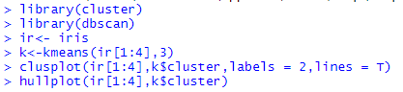

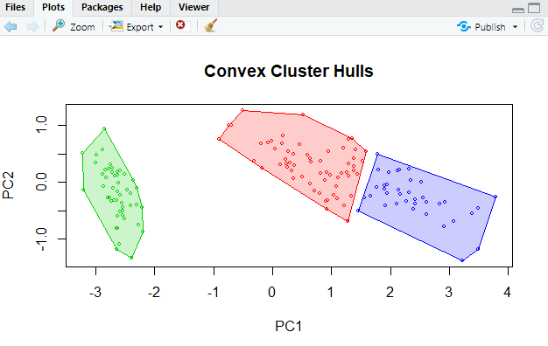

# Agglomerative Hierarchial Clustering



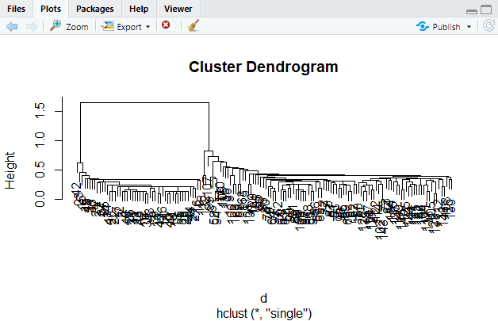

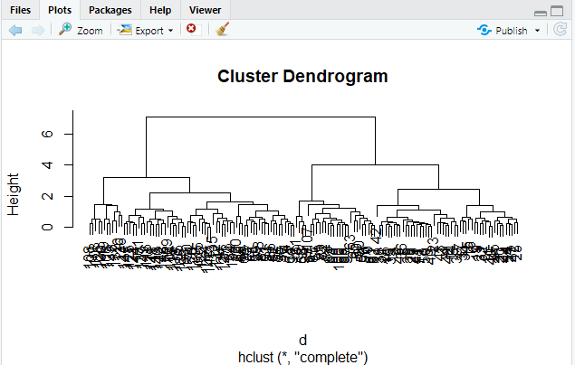



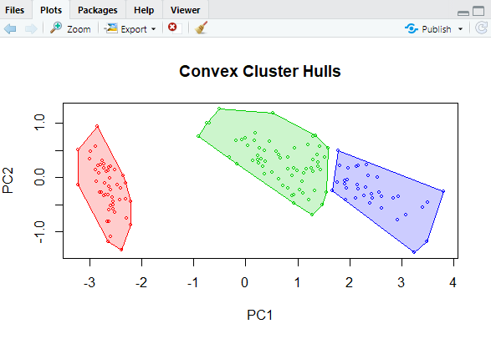

# DB Scan

